New Mexico MMIS Replacement (MMISR)
Concept of Operations
(ConOps)

Version: 11.0
Last Modified: December 21, 2018

[Concept of Operations Template MECT 2.3]

REVISION HISTORY

Version | Date | Description of Changes
1.0 | 10/5/2016 | Baseline Version
3.6 | 2/10/2017 | Latest update, adding content
4.0 | 4/6/2017 | Section updates; content assignments
5.0 | 4/19/2017 | Final updates to draft; soliciting SME input
6.0 | 8/30/2017 | Reopening to more explicitly state what the Integration Platform of HHS 2020 must achieve and how it will work
7.0 | 9/29/17
8.0 | 9/5/18 | Latest update including Business SME input/edits
9.0 | 10/18/18 | Latest updates to reference technical architecture sections
10.0 | 12/7/18 | Latest updates including business review
11.0 | 12/21/18 | Technical element synchronization with latest versions of Reference Architecture and MITA TMS

TABLE OF CONTENTS

1 Introduction 7
2 Referenced Documents 7
3 Current System 8
3.1 Functional Description 8
3.2 User Community Description 12
3.3 Technical Architecture 12
4 Goals, Objectives, and Rationale For New System 14
4.1 Project Purpose 16
4.2 System Goals and Objectives 16
4.3 Proposed System 17
4.3.1 System Scope 17
4.3.2 Business Processes Supported 18
4.3.3 High Level Functional Requirements 18
4.3.4 Summary Of Changes 21
5 Scenarios Analysis 21
6 Factors Influencing Technical Design 22
6.1 Relevant Standards 22
6.2 Assumptions and Dependencies 23
6.2.1 Open Architecture 23
6.2.2 Phased Parallel Implementation by Multiple Vendors 23
6.2.3 Outsourced Development, Hosting and Support 23
6.2.4 Implement Governance of Data and Architecture 24
6.2.5 Build Reusable Artifacts 24
6.2.6 Enforce Federal Standards and Guidelines 24
6.2.7 Follow Rigorous Enterprise Architecture Standards 25
6.3 Constraints 25
6.3.1 Hardware or Software Environment 25
6.3.2 End-User Environment 25
6.3.3 Availability of Resources 25
6.3.4 Constraints Placed on Vendors 25
6.3.5 Interoperability Requirements 26
6.3.6 Interface/protocol Requirements 26
6.3.7 Data Repository and Distribution Requirements 26
6.3.8 Autonomous and Decoupled System Assets 26
6.3.9 Leverage Shared SOA Capabilities 26
6.4 Design Goals 27
7 Proposed System 28
7.1 Context Diagram 28
7.2 Architecture of MMISR 34
7.2.1 MMISR High Level Functional Architecture 34
7.2.2 Operational/Hosting View of MMISR 39
7.2.3 The Integration Platform 40
7.2.4 User Transaction View of MMISR 43
7.2.5 Data Conversion Architecture – The System Migration Repository (SMR) 56
7.3 High-Level Operational Requirements and Characteristics 58
7.3.1 User Community Description 59
7.3.2 Non-Functional Requirements 59
7.4 High Level Architecture And Alternative Analysis 63
7.4.1 Application Architecture 67
7.4.2 Information Architecture 68
7.4.3 Interface Architecture 78
7.4.4 Security & Privacy Architecture 80
8 Analysis Of The Proposed System 82
8.1 Impact Analysis 84
8.2 Operational Impacts 84
8.3 Organizational Impacts 84
8.4 Risks 85
8.5 Issues to Resolve 86
8.6 Critical Success Factors for Remainder of Project 87
9 Glossary 88
Appendices 89
Appendix A Scenarios Analysis 89
Detailed design scenarios for the integration platform 89
Detailed design scenarios for the Data Services (DS) module 90
Detailed design scenarios for the Financial Services (FS) module 92
MMISR Vision Work Flows 93
Appendix B Conceptual Information Model 113
LIST OF FIGURES

Figure 1: Technical Architecture of Omnicaid 14
Figure 2: Context diagram of MMISR 29
Figure 3: Conceptual Architecture of MMISR 35
Figure 4: Shared Services Scope 38
Figure 5: High Level Deployment Architecture of MMISR 40
Figure 6: Details on the SOA-Based Design of the MMISR Integration Platform 41
Figure 7: MMISR Architecture Components participating in human use case realizations 44
Figure 8: Illustrative “Home” Page creation Component interaction sequence 50
Figure 9: Illustrative Non-Workflow Page Invocation Component interaction sequence 52
Figure 10: Illustrative Workflow (Initiating/Participating) Page Invocation Component interaction sequence 55
Figure 11: SMR Design 57
Figure 12: Pre-Go-live Data Integration Steps 57
Figure 13: MMISR Technology Architecture 64
Figure 14: NM MMISR IA Data Factory 69
Figure 15: From-To Overview of MMISR 83
Figure 16: Member Eligibility and Enrolment Flow 94
Figure 17: Member Updates to Eligibility and Enrollment Flow 95
Figure 18: Disenrollment of Ineligible Members Flow 96
Figure 19: Member Updates for MCO/FFS Selection Flow 97
Figure 20: Claims/Encounter Processing Flow 98
Figure 21: Capitation Process Flow 99
Figure 22: Other Payments Flow 100
Figure 23: Third Party Liability Flow 101
Figure 24: Drug Rebate Flow 102
Figure 25: Provider Management Flow 103
Figure 26: FSS Prior Authorization Flow 104
Figure 27: Other Recoveries Flow 105
Figure 28: Reporting Flow 106
Figure 29: Consolidated Customer Service Flow 107
Figure 30: Portal Inquiry Flow 108
Figure 31: Program Integrity Flow 109
Figure 32: Buy-In Flow 110
Figure 33: Presumptive (Provider) Eligibility Flow 111
Figure 34: Presumptive Eligibility (Member Application) Flow 112
Figure 35: NM MMISR Conceptual Information Model 113

LIST OF TABLES

Table 1: Referenced Documents 7
Table 2: List of Interfaces to MMISR 29
Table 3: List of Interfaces to MMISR 45
Table 4: MMISR Transaction Estimates 62
Table 5: MMISR Application Architecture 67
Table 6: Information Architecture Subject Areas 72
Table 7: NM MMISR IA Models 75

Introduction
The State of New Mexico (NM) Human Services Department (HSD) is in the process of designing, developing, and implementing a replacement MMIS. The goal of Medicaid Management Information System Replacement (MMISR) is to replace the outdated Omnicaid system, built by Conduent, which processes the Medicaid Management Information System (MMIS) business for New Mexico since 1996 and replace it with a Medicaid Information Technology Architecture (MITA)compliant system that meets the Center for Medicare Medicaid Services (CMS) Seven Conditions and Standards (SCS), and enables the MITA Maturity Model to track the capability maturity, improved outcomes for NM citizens, and enablement of an extensible Service Oriented Architecture (SOA)-based enterprise information system.
MMISR is being designed in context of an overall State initiative called HHS 2020, which is a multi-year, evolutionary plan to create an ecosystem where all New Mexico HHS departments can share infrastructure, shared services, and data. The goals and objectives for MMISR are in complete alignment with MITA 3.0, the Seven Conditions and Standards, and the MITA Maturity Model.

Referenced Documents
Table 1: Referenced Documents
Document Title | Relationship to Project
Conduent SOC1 Report | Service Organization Control Report for MMIS
The MMISR Update | Provides overview of MMISR project
RFP No. 1763040000002 HHS2020 MMIS-SI RFP; NM MMISR Systems Integration RFP | Defines the scope, work and requirements for the Systems Integrator procurement for MMISR
RFP No. 1763040000003 HHS2020 MMIS-DS RFP; NM MMISR Data Services RFP | Defines the scope, work and requirements for the Data Services procurement for MMISR
RFP No. 1863080000003; NM MMISR Quality Assurance RFP | Defines the scope, work and requirements for the Quality Assurance procurement for MMISR
Implementation Advance Planning Document (IAPD) for 11/07/2013 | Requests Initial Implementation funding from CMS for the Project
Implementation Advance Planning Document Update (IAPDU) for 07/27/18 | Requests Updated Implementation funding from CMS for the Project
MITA Technical Management Strategy (TMS) | Reinforces sound architectural design decisions

Current System
Omnicaid is the core and one part of the legacy New Mexico Medicaid Management Information System (MMIS). It maintains provider and client information, processes and adjudicates claims, and issues RAs and payments.
It is supported by three offices. The Albuquerque office maintains the daily operations for claims processing, interacts with providers for enrollment, claims, and client eligibility inquiry, and distributes warrants to providers for services performed. This office houses the Technical Services Unit who manages the Data Warehouse, the Business Service Unit who acts as both the system liaison to the State, performs testing of the Omnicaid application, and serves as the local IT support team who manages desktops and local hardware. The Systems staff located in Atlanta make all system changes, support the production environment and provide on-call support. The Pittsburgh Data Center provides related IT support teams and hosts the mainframe, servers, and other computing and networking hardware located in Pittsburgh, Pennsylvania. The Technology Services Group has staff in Atlanta and Pittsburgh to support production control during weekdays in addition to providing weekend support.

Functional Description
Provider Relations
Provider Relations assists providers with claim status, client eligibility, billing questions and program policies. The help desk responds to questions related to claim status, client eligibility and history for vision, dental and other services, provider enrollment application status, claim coding. They resolve billing and payment issues, research program policy and claims or refer to a provider field representative for follow-up. Provider relations interact with the provider community to solicit customer feedback and equip all provider types with web-based training. A toll-free telephone number is provided to enable customer service calls and track calls through Contact Relations Management (CRM) System. They measure the number of calls, abandonment rates, average talk time, average wait times, and number of calls routed to voice mail. They manage the provider relations mailbox by tracking and responding to inquiries; manage HIPAA help desk which provides the first level technical support and training for direct data entry of claims (Web portal) and EDI submissions; assist providers, billing agencies and clearinghouses (submitters) with questions about electronic claim submission through the electronic data interchange (EDI) translator. The HIPAA help desk representatives answer questions related to technical aspects of electronic claims submissions (EDI), confirm electronic claims have been received, troubleshoot electronic claims submission, technical issues and problems with HIPAA formatting (ASC X12). The HIPAA helpdesk manages the Trading Partner Management System (TPMS) by enrolling and disenrolling submitters, identify the transactions submitters can submit and their status. The HIPAA help desk manages and updates EDI companion guides as required.

Provider Enrollment
Omnicaid maintains comprehensive current and historical information about all Medicaid providers. The Provider Enrollment process verifies and maintains Medicaid provider enrollment applications, updates for all provider types within Omnicaid, processes provider recertification through the Turn Around Documents (TADs) process, enter provider updates, licensure updates, and Provider Action Requests (PARs), which are submitted via paper or web. They process memos (directives) from the State related to provider updates or enrollment, make outbound calls to providers requesting missing documents or information related to applications or updates.
Claims Management: Omnicaid handles all claims types submitted by providers either through direct electronic submission or on paper (manual entry or OCR) and encounters interfaced from MCOs. The Omnicaid system uniquely identifies each electronic claim when it is received from the EDI translator and assigns a Transaction Control Number (TCN). For paper claims, a TCN is printed on each claim when it is scanned by document control. Claims are monitored from the initial claim submittal to the final payment to each provider. The security and control over all claims information are maintained through function-level security defined by the State. Operations staff is responsible for resolving suspended claims through exception review and process adjustment requests.

Client Integration
Omnicaid maintains client eligibility and demographic data that is fed via an automated interface from the Integrated Eligibility System, referred to as the Automated System Program and Eligibility Network (ASPEN). Along with new information the client subsystem maintains an existing eligibility determination system, online update windows, supports claims processing, reporting, and other Omnicaid subsystems. Omnicaid supports enrollment of Medicaid clients in managed care health plans – including the maintenance of health plan eligibility criteria, coverage, and capitation rates for various client populations. Agents can identify categories of eligibility (COE) that are exempt from Centennial Care.
Medicaid Eligibility Quality Control (MEQC): The purpose of the New Mexico Medicaid Eligibility Quality Control (MEQC) subsystem is to assure State and Federal management that the State provides services to eligible clients, that services provided are appropriate and authorized, and that the payment for services is correct. The MEQC function provides automated sampling and reporting to support quality control reviews of claims submitted for clients.
Data Warehouse: The data warehouse is a set of data that has been copied from the Omnicaid mainframe system. The data is stored in columns (or fields), such as Transaction Control Number (TCN) or Client System ID. The major benefit of the data warehouse is that you can create ad hoc queries or reports that you would not otherwise be able to access through the Omnicaid system.

IBM Cognos Analysis Studio
Cognos is the component of IBM Cognos Business Intelligence that can use for multidimensional analysis and exploration of large data sources. The interactive drag-and-drop environment in analysis studio to explore and analyze data to find answers to business questions. Cognos query studio can be used as an alternative to Microsoft Access in order to obtain quick answers to targeted questions.

Customer Service Call Center (CSC)
The Customer Service Call Center is to assist clients with online enrollment into the New Mexico Public Assistance Programs and to answer questions regarding Medicaid, SNAP, TANF, and LIHEAP benefits. The CSC representative assists the recipient with completing the online application through the eligibility portal, YESNM. YESNM electronically replicates the paper application used at the Income Support Division (ISD) offices or downloaded by clients and then uploads directly to ASPEN. The CSC representative then notates the call in the CRM and ASPEN. They also communicate basic information regarding Medicaid, SNAP, TANF, and LIHEAP coverage, eligibility status and MCO provider selection, refers clients to the Income Support or Medicaid offices, processes client’s requests for MCO selections and updates, and processes requests for replacement ID cards. provide toll-free telephone number and track call statistics. The CSC representatives manage the YESNM mailbox by tracking and responding to inquiries.

Document Control/Scanning
The Document Control department receives paper claim adjustments, provider enrollment applications and updates, Medical Service Questionnaire (MSQ), Third Party Liability (TPL) updates, and general inquires. The document control sorts, organizes, and scans documents in preparation for entry into the document workflow system. The Document Control will process most paper claims through Optical Character Recognition (OCR) and electronically send to Conduent offices in Montana for review. OCR claims are directly uploaded into Omnicaid once the review is completed.

Pharmacy Claims
A Pharmacy Benefits Claim Processing Component (PBCPC) is managed to provide and maintain drug reference files and data, claim pricing, claims history, and drug reference files. It uses NCPDP standards and the Pharmacy Universal Claim Form (or similar) to capture data, support multiple payment methodologies allowing for variable dispensing fees, variable limitations on days’ supply for defined groups of providers or recipients, variable payment limits and restrictions, and reimbursements in accordance with federal regulations. It detects point of sale drug interactions, incorrect drug dosages, incorrect duration of treatments, clinical abuse or misuse, non-compliance/underutilization, overutilization, high costs and not using first drug of choice. The PBCPC reports on pharmacy payments, claims payments, physician and pharmacy profiles, client drug histories, costs, claims by client and pharmacy by month, refill rates, duration of therapies, and denied claims.

Drug Rebates
Drug Rebate Analysis and Management System (DRAMS) is used to convert invoice data for the Federal Drug Rebate program.
Third Party Liability: TPL staff identifies existence of insurance coverage and manage code reductions through cost avoidance or administering cost recovery cases, generates notices, recoup inappropriate payments to providers or clients, process insurance carrier refund requests, process trauma letters to clients (MSQ) and prepare TPL adjustments.

Financial and Accounting
Records all financial transactions such as advances, cost settlements, payouts to providers, warrants, refunds, overpayments, and third-party payments. Financial and accounting is responsible for issuance of remittance advices, warrants to providers, and distribute warrants and remittance advices to providers through mail or Electronic Funds Transfer (EFT). They are also responsible for handling refunds, creating financial transactions to account for these receipts, maintaining accounts receivables, payments and receipt of warrants based on inputs from various sources such as Accounting Transaction Requests (ATR) from the State, checks from providers and third-party insurers, and lost, missing, mutilated or stop payment checks.

Manage Reference Data
The reference subsystem is a central place where data is stored and maintained. This data is required for claims processing and other components of Omnicaid, such as procedure and diagnosis codes. The reference data managed is Healthcare Common Procedure Coding System (HCPCS) codes, Current Physician Terminology (CPT) codes, ICD-9 and ICD10 CM diagnostic, procedure and surgical codes, national coding system interfaces, Clinical Laboratory Fee schedule maintenance, and Durable Medical Equipment (DME) procedure fee schedules.
Continuous Quality Improvement: Quality personnel provide a verification of coding, keying, claims resolution and TPL activities through reviewing random samples of transactions. They review provider table maintenance requests for the State as well as reference table changes in the system They review all presumptive eligibility updates and completes a random sample of on-line updates. In addition, they develop and conduct training programs.

Manage Notices
Produce and distribute mail-out notices, reminders, alerts, newsletters, and bulletins to clients and providers; produce and mail managed care enrollment, re-enrollment, termination and confirmation letters.

Manage Interfaces
Internal interfaces and interfaces with external entities are necessary to support Omncaid functions. Interfaces are modified in response to changes in requirements and new interfaces are developed as necessary to support new program initiatives.

Disaster Recovery and Business Continuity
Policies and procedures for managing backups, recovery and regeneration processes, and priorities. The DR/BC includes the definition of roles and reporting mechanisms, the protection from disaster through multiple levels of hardware and software redundancy and the off-site storage of backup files that will allow recovery from unexpected failures without interruption in service except for the time required to activate and load backup software and files.

User Community Description
The users of the current Omnicaid system include staff from the Human Services Department (HSD)- Medical Assistance Division (MAD), Income Support Division (ISD), Office of the Inspector General (OIG), and other agencies including Aging and Long-Term Services Department (ALTSD), Department of Health (DOH), Children Youth and Families Department (CYFD), Providers, and MCO’s. Clients are able to access specific information via a web portal.

Technical Architecture
The following describes the technical architecture of the current MMIS system, Omnicaid (depicted in figure 1).
Omnicaid utilizes a three-tiered client-server architecture.
• Client workstations
• Sybase Enterprise Application Server middle tier
• Mainframe back end
The three-tier client-server architecture, used by the Omnicaid system, offers efficiencies over a simple two-tiered client-server model. In this implementation, the client tier is responsible for edit and front-end business logic. The middle tier provides an abstraction layer to back-end CICS transactions and DB2 database on the mainframe. This abstraction layer prevents the client software from having to be concerned with connection details, logging, record locking, and other common business functions.
The client workstations run Windows 7 Enterprise with PowerBuilder run-time and the client presentation layer of the Omnicaid application. The presentation layer contains front-end edit logic. The client windows presentation layer is built using Conduent-developed class libraries that provide a consistent user-interface and navigation.
The middle tier provides middleware connectivity to the database back-end and to six CICS transactions. It uses Sybase Enterprise Application Server (also referred to as “EA Server” or “Jaguar Server”) as a middleware application engine. This middleware layer provides access to CICS applications and DB2 on the back-end. It also provides clustering, load balancing, two-phase commit and fail over capability. The middle tier provides on-line business logic using PowerBuilder non-visual objects.
The middle and client tiers utilize PowerBuilder components deployed on the client and Sybase EA Server (Jaguar) on the middle tier. These CORBA compatible components communicate between client and middle tier using IIOP. Data is passed via compressed arrays of binary large objects (BLOBs). Components exist for most data objects and functional groups. They manage the transfer of data to and from PowerBuilder data windows.
The mainframe back-end runs IBM CICS and DB2 relational database management system. In addition to direct connection to DB2 by PowerBuilder components, the middle tier also invokes CICS transactions on the mainframe. The CICS transactions support Claims Inquiry Search, Claim Entry and Correction, Client Lock-in, Category of Eligibility Update, Client Merge and Prior Authorization Maintenance functions. CICS connectivity is provided via MQSeries. Connectivity to DB2 is provided to the middle tier and client workstations through IBM DB2 Connect. In addition to supporting middle tier and workstation transaction and data requests, the back-end is used to run all batch processes and reports as well as the claims engine.

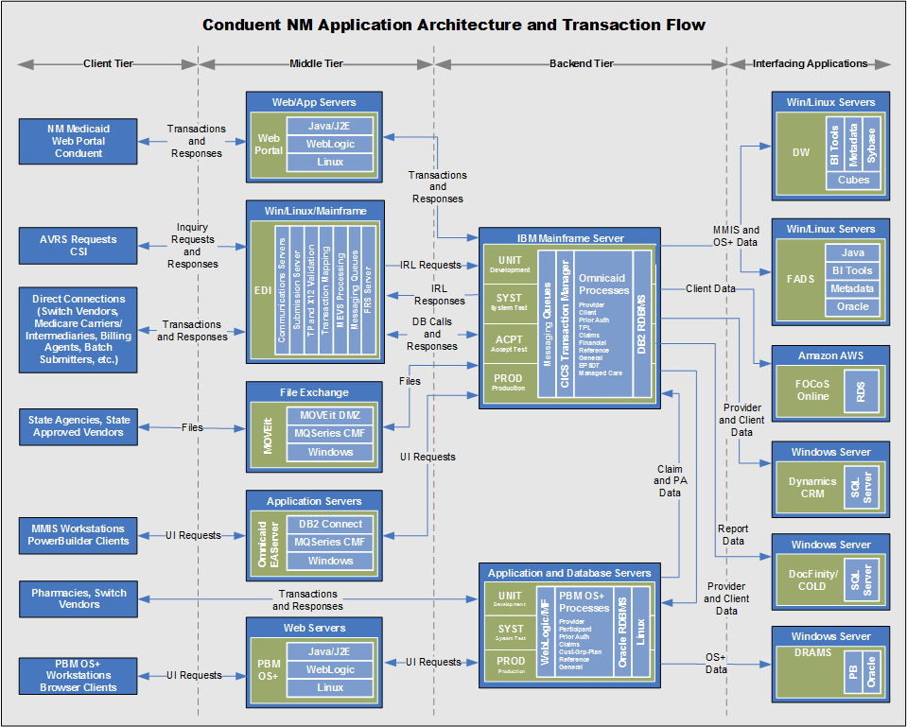
Figure 1: Technical Architecture of Omnicaid

Goals, Objectives, and Rationale For New System
HSD’s mission is to reduce the impact of poverty on people living in New Mexico by providing support services that help families break the cycle of dependency on public assistance.
This mission is supported best by a client-centric business solution that ensures that the programs are delivered as effectively and efficiently as possible. This is a significant departure from the current system, which supports a siloed system that is built on an aging architecture and is proving expensive to maintain and cost-prohibitive to evolve.
To this end, the goal for all new systems is to have a common architecture, providing common technology platforms, highly shared data, common tooling, and reusable capabilities, which will expand business capabilities and cross-program/cross-organizational sharing of data and results. The State must leverage enterprise architecture, technology platforms and acquired service capacity for multiple business needs across programs and across human service agencies, including HSD, DOH, CYFD, ALTSD and others that serve the citizens of New Mexico.
Historically, HSD and HHS programs and systems were developed and operated in silos, organized around processes that were the purview of different agencies. Major programs, such as Medicaid, traditionally are supported through very large, monolithic systems such as Omnicaid and typically developed and operated by a single contractor. Systems were typically proprietary “one off” solutions from a single vendor. Options for changes or improvements were expensive or not feasible. When these endeavors were undertaken, they were time consuming and risky to both the customer and the vendor. While this approach allowed successful program operation for decades, it also has a number of drawbacks, including:
- Large, monolithic systems are expensive to build and maintain, and often lack flexibility to respond quickly to programmatic, technology or information changes; and
- The program-centric approach and the attendant cost, redundancy, and lack of flexibility becomes embedded not just in technology but also in organization structure, processes, communications, data collection and reporting, and stakeholder interaction.
The MMISR vision is about a transformational, enterprise-wide approach to the human services business. Fundamentally, MMISR is about moving from a series of inflexible systems and program-centric implementations to an enterprise-wide, highly shared infrastructure and stakeholder-centric solutions. This involves moving to an open, flexible framework that supports business and system agility through service provision and stakeholder interaction across HHS programs and organizations.
MMISR is technology-enabled but represents much more than that including rethinking organizational design, redesigning and streamlining business processes, and reducing barriers between organizations within the HHS enterprise. The MMISR implementation is focused on HSD programs and systems, however, the vision is to include the entire HHS enterprise serving all HSD divisions and other HHS organizations such as the DOH, CYFD, ALTSD and more.
The MMISR vision takes a fresh look at how to obtain needed support moving from a single vendor’s proprietary technology to a combination of open technologies and outsourced services that take advantage of commodity capabilities in the marketplace. With MMISR, HSD is increasing its focus on data, which is the key to understanding and more effectively planning, delivery, management and assessment of human services programs. These goals align completely with the Medicaid Information Technology Architecture (MITA), the MITA Maturity Model and the Seven Conditions and Standards.
By adopting a modular approach that blends technology components with Business Process Outsourcing (BPO) solutions, HSD anticipates realizing the following benefits:
- Opportunity to support an outcomes-based approach to planning, delivering and assessing service delivery, focusing on the end impact and value to New Mexico citizens instead of on internal processing requirements;
- Realization of a customer-focused approach to service management and delivery that can make it easier for New Mexico citizens to understand and receive needed services and for providers to interact with the State;
- Increased ability to respond promptly and insightfully to changing program or population needs;
- Enhanced ability to operate in a dynamic environment with increasingly restricted funding without degrading service levels, by leveraging modern, standards-based technologies;
- Greater flexibility to take advantage of rapidly evolving technology to achieve service improvements and/or to reduce maintenance and operation costs; and
- Reduced redundancy through enterprise-wide sharing of technology, services, data and processes to deliver high-quality customer service.
The foundation of New Mexico’s MMISR vision is a modular framework comprising both technology and outsourced applications/solutions. The MMISR framework is designed to provide a scalable, integrated and shared technology and services framework that can readily support the HHS enterprise.
The framework emphasizes modularity coupled with interoperability, achieved through a standards-based approach to implementation and through widespread adoption of a Service-Oriented Architecture (SOA). Additionally, it emphasizes reuse of existing NM investments in applications and technology infrastructure as much as possible without adversely affecting long-term performance, flexibility or sustainability. For example, HSD’s integrated eligibility system, ASPEN is considered a future part of the MMISR framework once it is integrated.

Project Purpose
The purpose of MMISR is to create a modernized MMIS system that is aligned with MITA and Seven Conditions and Standards, and therefore better aligned with nationwide CMS and other federal initiatives. A secondary purpose is to create the first instance of an ecosystem that implements significant portions of the HHS 2020 architecture, delivering reusable components and technologies that will enable it to serve the needs of other organizations and programs. A third purpose is to reduce the demand for State resources for hosting and maintaining system components by outsourcing different aspects of the ecosystem to different contractors.

System Goals and Objectives
This integrated enterprise technology and services approach will:
- Provide a one-stop access point to support a person-centric model beginning with initial contact or outreach (e.g., Program Socialization, Information Sharing, Exploration, etc.) through benefit coordination and reconciliation,
- Support integrated user access, robust self-service for eligibility application and determination, and enhanced service delivery and case management coordination across State programs,
- Improve experiences and outcomes for internal and external Stakeholders,
- Enable improved creation of applications through the use of modern Business Process Management, Workflow, Orchestration and Business Rules Engines,
- Establish and leverage the agility and adaptability of a Service Oriented Architecture (SOA),
- Provide improved Enterprise data quality, accuracy and timeliness, and higher degrees of data sharing,
- Establish master data management for Client, Provider, Employer and other data,
- Bring more adaptable, real-time reporting, analytic and business intelligence tools to Enterprise users that leverage highly shared, cross-program information, and
- Implement a shared services approach that can provide common technology components and capabilities to improve information integration.
The benefits of this approach are:
- Improved citizen access to Health and Human Service programs,
- Strengthened and improved outcomes of services, preventing costlier publicly funded services,
- Targeted interventions by and across programs, and
- Reduced cost of services through prevention of duplication, waste, uninformed decision-making, fraud, and abuse.

Proposed System
MMISR implements all the functionality to support MMIS operations, while building out the first instance of the enterprise-wide architecture. In so doing, MMISR establishes a flexible, extensible, sharable, robust, secure, high-performing SOA-based system, while delivering system components that can be leveraged by other HHS organizations and even other States.

System Scope
The MMISR system will encompass all the services required to support the Quality Assurance (QA), Benefit Management Services (BMS), and Financial Services (FS) business areas. It will also integrate with the existing ASPEN system, which will provide real time eligibility and enrollment functionality. All functionality required to implement MMIS will be included in different modules of MMISR .
It will enable internal and external user access via a single unified portal, which will interact with services that support these business areas through orchestrated and atomic business services. It will also unify all business analytics through a single Data Services (DS) system. Furthermore, it will deploy reusable, core shared services such as Master Data Management (MDM), address standardization, document management, and common tooling to construct and integrate existing and new components into new HHS capabilities.

Business Processes Supported
The MMISR will support all MITA business process areas and the corresponding business processes. In addition, the MMISR will support other business processes outside of MITA that are specific to the business. Business Process Redesign (BPR) work is being completed to identify all business processes to ensure the MMISR can support those business processes.

MMISR functional requirements are assigned to seven unique MMISR functional modules: System Integrator (SI), Data Services (DS), Unified Portal (UP), Quality Assurance (QA), Benefit Management Services (BMS), Financial Services (FS) and Consolidated Customer Services Center (CCSC). The SI, DS and UP modules are the technical components that facilitate interoperability between business processes and internal and external users as well as oversight for the performance of outsourced business services for QA, BMS, and FS.

High Level Functional Requirements

System Integrator
The SI provides and manages the Integration Platform (IP), performs Application Programming Interface (API) Management, provides API Governance, performs Module Integration Planning, provides input to the State led Organizational Change Management Planning process, participates in various Governance groups such as Data Governance and Architecture Review Board, provides MITA Strategy Integration, provides Enterprise Architecture (EA), performs Fit/Gap analysis of modules to EA and IP, performs Module Integration, provides Certification Integration, provide SI Project Management and oversees the adoption and integration of Project Management standards across the modules; provides shared services such as document management, workflow orchestration, and data migration.

Data Services
The DS Contractor delivers a Solution applying SOA principles and design; provides Certification support and integration; provides DS module Project Management; supports Data Governance; ensures the security and integrity of data; delivers and supports data reporting, analytics and business intelligence tools; delivers an enterprise-wide platform for common reporting and BI/Business Analysis (BA) capabilities.

Unified Portal
Unified Portal (UP) will act as one-stop environment to the current and prospective clients to enhance usability of the current tools and systems used by clients on a day to day activity. The UP ensures that users can navigate the internal or external portals through a graphical user interface; uses workflows to assist users in specific processes; interfaces with the SI platform; assists with identity governance for users; provides multi-factor authentication to access the portal; supports members, providers and internal users such as state employees.
The internal portal will provide the users with workflows that are essential in fulfilling their duties. This will act as a repository for assigned tasks, access training material, shared files, in addition to electronic communication. The portal will allow users access to all tools and applications based on their using the portal as a gateway to data from different applications. The portal will allow access to selected news feeds including system maintenance, and upcoming releases. The portal platform will allow internal users the ability to add links to external sites i.e. Motor Vehicle (MVD), Department of Workforce Solutions (DWS) sites as needed. Additionally, users will have access to the portal via a single sign on.
The external/customer portal is a unified interface serving all Stakeholders, in keeping with the vision of presenting a more customer-centric view of Health and Human Services (HHS) services and processes. HSD seeks to develop, implement and operate a Unified Public Interface (UPI)/UP serving New Mexico citizens, Providers, State agencies and employees and other Stakeholders. The goal of the UPI, when paired with the CCSC, is to offer a “one-stop shop” that embraces a “no wrong door” approach to customer service.

Outsourced Business Processes
Outsourced business processes, for MMISR, is the outsourcing the operations and responsibilities of sets of specific business processes to a service provider with oversight by the State. These outsourced services are separate business functions and are responsible for performing processes or parts of processes and done to save costs or gain productivity. The focus is not on the technology of the outsourced services but on the ability to ingest MMISR data, process the data in an expected manner and provide quality data back to the State via the SI module and for oversight or population health management via the DS. HSD intends for the BPO modules to function as “black boxes”, in that the inner workings of the outsourced contractor’s enabling technology are not specified by the State, but rather that the module is viewed in terms of functionality, business process efficiency, performance against SLAs, and data inputs and outputs, enabling the State to take advantage of commodity services in the marketplace to achieve rapid use of key services needed to support Medicaid.

Common Functionality
Outsourced business process vendors, in addition to their own specific functional requirements, share common functional requirements to support data exchange and process automation via the SI’s integration platform, follow and enforce state privacy and security requirements, manage the integration of each module’s specific project management processes into the overall SI project management processes, maintain expected levels of availability and customer support, provide data to DS via the SI integration platform, provide disaster recovery and business continuity, follow SI established plans and state established governing board policies, provide training and materials to users, provide assistance and evidence during certification, and provide seamless knowledge and data transfer in the event services are to be terminated.

Quality Assurance
The QA module provides services for four (4) essential business component areas: 1) Program Integrity (PI) support, including Third-Party Liability (TPL), Fraud and Abuse Detection Services (FADS), and audit coordination and compliance; 2) Management of Recovery and Audit responsibilities; 3) Quality Reporting; and 4) Coordination of efforts and projects with the HSD Office of Inspector General (OIG) and the Medicaid Fraud Control Unit (MFCU) of the Office of the Attorney General (OAG).

Benefits Management
The BMS module provides services for member management (Early Periodic Screening Diagnosis and Treatment (EPSDT) and other member data), assistance with a care and case management tool to provide data tracking necessary for effective care and case management within and across HHS 2020 agencies (Care/Case Management Tool), Utilization Management (UM)/Utilization Review (UR) (e.g., Prior Authorization and other authorizations, ISP/SSP, ICF-MR, LOC, POC), Provider Management (Enrollment and Credentialing), Electronic Health Records (EHR) Program Coordination (Attestation and Meaningful Use), Pharmacy Benefit Management (Authorization, Claims, Drug Utilization Review (DUR), Drug Rebate), Assistance with Managed Care Organization (MCO) Management, and Benefit Plan Management (BPM).

Financial Services
The FS module provides services for financial transactions which includes accounting and fiscal agency, billing and payment receipts; claims processing to include ingesting and adjudicating claims; data exchange and reporting to includes providing Enterprise required data, providing “out of the box” reports and the ability to using Enterprise data.

CCSC
The CCSC module provides all required contact center services for the New Mexico Human Services Department Medical Assistance Division (MAD); Income Support Division (ISD); Child Support Enforcement Division (CSED); Behavioral Health Services Division (BHSD); Office of Fair Hearings Bureau (FHB); and the Office of the Inspector General (OIG); with consideration for integrating other Bureaus or Agencies in the future, such as, Restitutions Bureau, Constituent Services, Department of Health (DOH); Aging and Long Term Services (ALTSD); and Children Youth and Families Department (CYFD).

Summary Of Changes
The existing system is not being changed as NM is proposing a full system replacement.

Scenarios Analysis
The following scenarios described in Appendix A shows how the MMISR will be used to support different business processes in the MMIS. These scenarios reflect touchpoints where applicable in each BPO and systems for the various business processes. The NM HSD workers will access the different systems and services through the internal portal of the Unified Portal system to perform work that may require manual intervention. The functionalities that the worker will be able to perform will be based on their User Role which will be assigned by NM HSD. The MMISR modules will use the workflow engine that reside in the IP to coordinate orchestration between each BPO for work that may be assigned to workers outside of their respective BPO. For work that will be assigned to a worker within a BPO, the worker will rely on the internal workflow for those that may require manual intervention. State workers are relying on automation of the systems and services to perform most business processes. The worker will also leverage the Enterprise Content Management (ECM) System and Customer Communication Management (CCM) System which is hosted in the IP. The worker will use the ECM to scan and retrieve documentation that will be used to process cases for Fraud and Abuse, perform accounting functions, process claims, process Provider application etc. The CCM will be used to send communication to clients and providers, alerts and notifications. These touchpoints have not been identified for each business processes.

Factors Influencing Technical Design
This section describes the standards, assumptions, and constraints that influence the technical design of the proposed system.

Relevant Standards
MMISR will adhere to numerous Federal and Industry standards in its architecture, design, testing and implementation:
- Health Insurance Portability and Accountability Act (HIPAA) standard transactions and HIPAA code sets for transaction processing
- HIPAA security and privacy standards across the MMIS
- National Institute of Standards and Technology (NIST) for security
- Federal Information Security Management Act (FISMA) of 2002
- Patient Protection and Affordable Care Act (ACA) Section 1104 and Section 1561 transaction standards and operating rules
- User interfaces/web portals meeting the guidelines of the Americans with Disabilities Act (ADA) and Section 508 of the Rehabilitation Act of 1973
- Health Level Seven International (HL7), including Fast Healthcare Interoperability Resources (FHIR), and Nationwide Health Information Network (NwHIN) standards in the larger healthcare ecosystem
- Medicaid Information Technology Architecture (MITA) Framework 3.0
- MITA Technical Management Strategy 3.0
- Seven Conditions and Standards
- Medicaid Enterprise Certification Toolkit v2.3
- Institute of Electrical and Electronic Engineers (IEEE) standards for software development
- NIEM – (National Information Exchange Model)
- Service Oriented Architecture (SOA)
- EDIE (Emergency Department Information Exchange) Records System Standards
- Health Information Technology for Economic and Clinical Health (HITECH) Act
- National Information Exchange Model (NIEM)
- CMS Minimal Acceptable Risk Standards for Exchanges (MARS-E) 2.0 (2015)
- Internal Revenue Service (IRS) Publication 1075
- Payment Card Industry Data Security Standard (PCI DSS)
- New Mexico Administrative Code (NMAC) 1.12.20, Information Security Operation Management
- Social Security Administration (SSA) Office of Systems Security Operations Management Guidelines
- Federal Health Information Model (FHIM)

Assumptions and Dependencies
MMISR is being architected, designed, implemented and operated within context of a much larger and more extensible architectural vision, and incorporates the following assumptions and dependencies:

Open Architecture
MMISR is built on an architectural model that is open by its very nature, allowing systems to be added, updated, and replaced as business or regulatory changes dictate. Since it is built as an open architecture, following SOA standards and open architectural design principles, it is designed to offer shared infrastructure, shared tools, shared best practices, shared components (services), shared data, and shared design models.

Phased Parallel Implementation by Multiple Vendors
One of the assumptions and the approach of the MMISR project is to procure different functional components of MMISR from different vendors, who will each deliver their functional systems/components at different times. This places a dependency upon aligning the conversion of data from the legacy Omnicaid system to the new capabilities and creating a robust testing and implementation plan. The Systems Integrator contractor will be largely responsible for aligning and coordinating the work of other BPO vendors in delivering, integrating, testing and implementing their individual systems.

Outsourced Development, Hosting and Support
MMISR will be developed and delivered by multiple BPO vendors. While that will have no visible impact on the users of the system, it will slightly complicate the administration and support desk for the various components.
The portion of the solution hosted by the State, including the Unified Portal, Enterprise Application Integration, Enterprise Service Bus, Business Rule Engine, EDI portal, Business Process Management, System Migration Repository and Master Data Management will be hosted for production purposes out of the State datacenter using a combination of physical hardware and virtualization software. Development and Disaster Recovery environments will be located in the Oracle Government Cloud.
Modules sourced from BPO partners will be hosted by their respective vendors outside of the State’s infrastructure.

Implement Governance of Data and Architecture
In order to get several vendors to work seamlessly together who will be at different stages of design, construction, testing and implementation at different times, enterprise governance will be required in several areas. Two areas of importance are for Data Governance and Architectural Governance. Since data will be created, updated and shared across disparate applications, by different groups of users, data sharing will require strong governance. These highly shared data will be codified into standardized data sharing mechanisms (messages and shared data schemas) and will become the “lingua franca” of integration in a SOA-compliant distributed ecosystem, requiring strong Data Governance.
Also, since different vendors will deploy services at different times both for MMISR and other HHS projects, those services must conform to architectural standards for design, construction and testing, so that all the “moving pieces” work seamlessly together. This requires strong Architectural Governance that will ensure Business Architecture, Information Architecture and Technology Architecture are integral to the design, testing and delivery processes.

Build Reusable Artifacts
One architectural mandate is to build and deploy reusable, shared artifacts. This may be in creating reuse in architectural, design, development and testing documents and plans. It will certainly be in designing and deploying reusable services and message schemas. This will require strong governance, as mentioned above, but it will also require a level of maturity in practitioners to create artifacts that are meant to be shared outside a particular system’s needs. This maturity will be evidenced in their willingness and ability to collaborate across vendor and system boundaries, under the guidance of State governance, and to adapt their own proprietary styles of creating artifacts State needs to create reusable artifacts.

Enforce Federal Standards and Guidelines
The MMISR vision and enterprise architecture is not designed in a vacuum. It is assumed that each architectural and design mandate will be drawn from one or more Federal and State standards for architecture, design, construction, testing and delivery. It is also assumed that some delivered artifacts will undergo review and possible certification by CMS and other agencies in the future (NHSIA and SAMHSA) to ensure compliance with the standards and guidelines listed in section 6.1 above.

Follow Rigorous Enterprise Architecture Standards
For every component, service or capability that is meant to be exposed or shared outside the boundaries of a particular BPO, the architecture and design of those components will rigorously follow State architectural standards, as administered and measured by the HSD Architecture Review Board (ARB). The depiction of those components’ designs in drawings and specifications, as well as their construction and testing, will conform to NM MMISR Enterprise Architecture standards, and therefore to MITA standards.

Constraints
The following convey known constraints that may have a significant impact on the design of the MMISR system.

Hardware or Software Environment
There are no known constraints on hardware or software, but all new implementation and hosting designs must conform to MMISR Technical Architecture standards and recommendations.

End-User Environment
The only constraint on the end-user environment is that it must be compatible with the Liferay platform chosen by the State’s Unified Portal team. The design of the portal, portlets and web interfaces will be vetted through participation in the MMISR architectural review process, where detailed constraints will be published for all vendors.

Availability of Resources
There are no anticipated constraints on the resources available to vendors in the design, construction, testing and delivery of their components. As in most projects, business users will be participating in JAD and similar design sessions, which will impose a drain on those resources, but since each MMISR module vendor will be starting at different times (different months and quarters), it should spread out the need for business users.

Constraints Placed on Vendors
All designs must be approved by the Architecture Review Board (ARB), which is comprised of State technology executives, senior architects, designers and engineers. The ARB is responsible for ensuring architectural design consistency, completeness, accuracy and compatibility across all MMISR programs, projects, procurements, designs and systems.

Interoperability Requirements
There are no known interoperability constraints that would be any different than any MMIS environment, where the system components must share data via FTP, EDI, web services/SOAP, and similar file exchange mechanisms (X12, HL7 and other batch interfaces).

Interface/protocol Requirements
Constraints for interfaces and interface protocols will be imposed by the adherence to SOA and the platform standards. Interfaces must be asynchronous and stateless as much as possible. They must also use standard schema definitions (according to the MMISR Information Architecture), approved by the Data Governance Council and the ARB, and administered by the SI vendor. All interfaces must use only standard nomenclature for identifying schemas, messages, contracts, and service signatures.

Data Repository and Distribution Requirements
Vendors’ systems will manage data internally according to whatever COTS persistence management their individual system requires. When a vendor needs to share or accept data with any other service through the MMISR platform, they must convert their private schema to a shared schema as enforced by the Integration Platform and integrate by exchanging messages with other services/systems. Individual systems are constrained from using point-to-point, tight coupled interfaces such as direct database connections across platforms, or other remote procedure call methods. The messages and the schemas used to exchange data between systems and services will conform to MMISR Technology Architecture standards and guidelines.

Autonomous and Decoupled System Assets
All vendor services that are exposed for sharing throughout the MMISR ecosystem must be decoupled from other services and must be autonomous. Autonomy will be partially guaranteed by each service managing its own internal persistence, not in using shared data stores, as this creates coupling and interdependencies that hinder service autonomy. The designs of individual services and their levels of decoupling will be approved by the ARB.

Leverage Shared SOA Capabilities
Vendors will share the same SOA infrastructure, which may be hosted in a completely different environment, for sharing and integration via SOA. Vendors will be encouraged to leverage the same SOA tools that other systems/projects within MMISR will leverage. These may include a common Business Process Management (BPM) tool/platform, a common Workflow tool/platform, a common Business Rules Engine (BRE), as well as a common XML mapping tool.
Vendors will use the same security services hosted in the Integration Platform. These will provide consistent Single Sign on (SSO) capabilities as well as services for securing data in transit such as encryption/decryption, compression/decompression, monitoring and auditing.
Any departures from these standards must be documented and approved by the ARB.

Design Goals
As MMISR is the first instance of a system designed in accordance with a larger NM HHS vision, it will adhere to these high-level design goals:
- All parts of MMISR must meet State and Federal regulations and the requirements of Chapter 11 of the State Medicaid Manual.
- MMISR must meet MITA guidelines, the Seven Conditions and Standards, and must enable the organization to reach MITA Maturity Level 4.
- The following is a brief list of the most important design goals of the MMISR system:
  - Compliant with a long-term, modern, SOA-based architecture
  - SOA design compliance; composite applications, compliant with MITA Business Architecture
  - Autonomous and Loosely-coupled components
  - Interface by contract, managed by an ESB
  - High degree of reusability within and outside of New Mexico
  - Standard message schemas (in line with NIEM, HL7 and other standards)
  - Consistent data models, compliant with Information Architecture
  - Use of modern service components like Master Data Management
  - No non-standard uses/extensions of tools
  - Localized/Isolated scaling
  - Systemic security, auditing, logging
  - High Availability for the system and near-Continuous Availability for core, highly shared components such as the Integration Platform and shared services
  - Leverage existing licenses wherever possible to reduce costs and increase resource utilization

Proposed System
MMISR is the first implementation of a long-term vision for system interoperability, sharing, and improved outcomes for citizens and State resources.

Context Diagram
The following Context Diagram shown in Figure 2 shows the types of external entities (organizations, people and systems) that will interface with MMISR. Each of these is representative of numerous instances of actual organization, people and systems that are detailed in below.
Figure 2: Context diagram of MMISR
Table 2 below depicts an inventory of interfaces grouped by the major actor groupings in Figure 2 above.

Table 2: List of Interfaces to MMISR
External Entity Group | External Entity Name | Data Flows | Inbound Interfaces (From) | Outbound Interfaces (To) | Frequency | Type
External Partners (Commercial) | Finity | 1: Client- eligibility |  | 1 | Monthly | Batch
 | HMS | 1: Client- DOD and TPL  2: Client-TPL, Error and Claims and Valid Value Definitions | 2 | 5 | Daily | Batch
 |  |  |  |  | Daily | Real Time
 |  |  |  |  | Monthly | Batch
 |  |  |  |  | On Request | Batch
 | Qualis | 1: Client- prior authorization; LTC  2: Client- prior authorization error, LTC error, eligibility, eligibility error, and Provider | 2 | 5 | Daily | Real Time
 |  |  |  |  | Weekly | Batch
 |  |  |  |  | Monthly | Real Time
 | Spectrum Informatics | 2: Client-eligibility, reference, valid value definitions |  | 3 | Weekly | Batch
External Partners (Payors/ MCOs) | BCBS | 3: LTC data; TPL; LTC error file, Encounter File  4: 2-Enrollment; LTC; Health Homes; Client, TPL, Carrier, Payment, Provider, Formulary | 4 | 9 | Daily | Batch
 |  |  |  |  | Monthly | Batch
 |  |  |  |  | Monthly | Real Time
 | UHC | 3: LTC data; TPL; LTC error file, Encounter File  4: 2-Enrollment; LTC; Health Homes; Client, TPL, Carrier, Payment, Provider, Formulary | 4 | 9 | Daily | Batch
 |  |  |  |  | Monthly | Batch
 |  |  |  |  | Monthly | Real Time
 | MHP | 3: LTC data; TPL; LTC error file, Encounter File  4: 2-Enrollment; LTC; Health Homes; Client, TPL, Carrier, Payment, Provider, Formulary | 4 | 9 | Daily | Batch
 |  |  |  |  | Monthly | Batch
 |  |  |  |  | Monthly | Real Time
 | PHP | 3: LTC data; TPL; LTC error file, Encounter File  4: 2-Enrollment; LTC; Health Homes; Client, TPL, Carrier, Payment, Provider, Formulary | 4 | 9 | Daily | Batch
 |  |  |  |  | Monthly | Batch
 |  |  |  |  | Monthly | Real Time
External Partners (Systems) | Conduent | 5: Client- merges, prior authorization remaining units, and by case manager and Provider-rate and formulary files |  | 5 | Daily | Real Time
 |  |  |  |  | Monthly | Batch
Federal Agencies | CMS | 6: Medicare,  7: Claims, Provider, TPL, Eligibility, Managed Care | 11 | 8 | Monthly | Batch
 |  |  |  |  | Monthly | Real Time
 | IRS | 7: Client |  | 1 | Annually | Batch
 |  |  |  |  | Monthly for three months | Batch
HHS Departments | ALTSD | TBD | TBD | TBD | TBD | TBD
 | CYFD | TBD | TBD | TBD | TBD | TBD
 | DOH | 8: Client-prior authorization, eligibility  9: Client-prior authorization error, eligibility error, and Claims | 2 | 4 | Daily | Batch
 |  |  |  |  | Daily | Real Time
 |  |  |  |  | Weekly | Batch
 |  |  |  |  | Monthly | Batch
 | HSD/ASD | TBD | TBD | TBD | TBD | TBD
 | HSD/BHSD | 8: Client | TBD | 1 | Daily | Real Time
 | HSD/CSED | TBD | TBD | TBD | TBD
 | HSD/Fair Hearings Bureau | TBD | TBD | TBD | TBD
 | HSD/OIG | TBD | TBD | TBD | TBD
 | HSD/OGC | TBD | TBD | TBD | TBD
 | HSD/ Restitutions Bureau | TBD | TBD | TBD | TBD
 | HSD/ITD | 9: Claims | TBD | 2 | Weekly | Batch
State Agencies | DFA | 10: 1099  11: Vendor, Voucher | 1 | 2 | Daily | Batch
 | AG | 11: ad hoc reports; Claims (future interface)
External Systems | EHR | 12: State Level Registry, |  | 1 | Weekly | Real Time
 | FOCoS | 12: Eligibility |  | 1 | Daily | Batch
Internal Systems | ASPEN | 13: Client- Eligibility, TPL and Managed Care  14: Client-Eligibility response; Eligibility error, TPL, TPL error, and MCO error and valid values | 3 | 7 | Daily | Batch
 |  |  |  |  | On Request | Batch
 | PBMS | 13: Prior Authorization, Pharmacy, Claims  14: Client- Eligibility, merges, Provider, Pharmacy, Prior Authorization, Claims, | 5 | 9 | Daily | Real Time
 | SHARE | 14: financials for reporting; vendor file and warrant file and EFT file | 1 | 3 | Daily | Batch
 | Omnicaid | 18: Legacy system data conversion through SMR | all |  | Once, then changed data capture | Batch ETL
Consumers | Consumers | 15: PII, PHI, PFI, Enrollment, Case details  16: Eligibility, Account details (PII, PHI, PFI) | 1 | 1 | Daily | Real Time
HSD Users | HSD Users | 17: all business transactions |  |  | Hourly | Real Time UI

Architecture of MMISR
This section presents several depictions of the architecture of MMISR, each from a different perspective. Together, they define how components of MMISR are separated and aligned to achieve long-term architectural goals, and how the components of MMISR work with end users and external systems (through the Integration Platform).

MMISR High Level Functional Architecture
Figure 3 shows a high-level depiction of how the different technologies that comprise MMISR are grouped together, and how they are separated into different “tiers” that separate user access from underlying systems. It also depicts the architectural principles of separation of concerns, loose coupling and Service Orientation at a very coarse-grained level of abstraction. MMISR will leverage a mature SOA design and implementation approach to host decoupled, autonomous applications that support various HHS business areas, producing and using shared services.
Not shown explicitly in Figure 3, MMISR is a virtual ecosystem, in that the disparate systems and technologies that comprise MMISR may be hosted in any number of different environments, but the interdependencies and interactions are irrespective of hosting details. For a discussion on hosting architecture, see Figure 3 below.
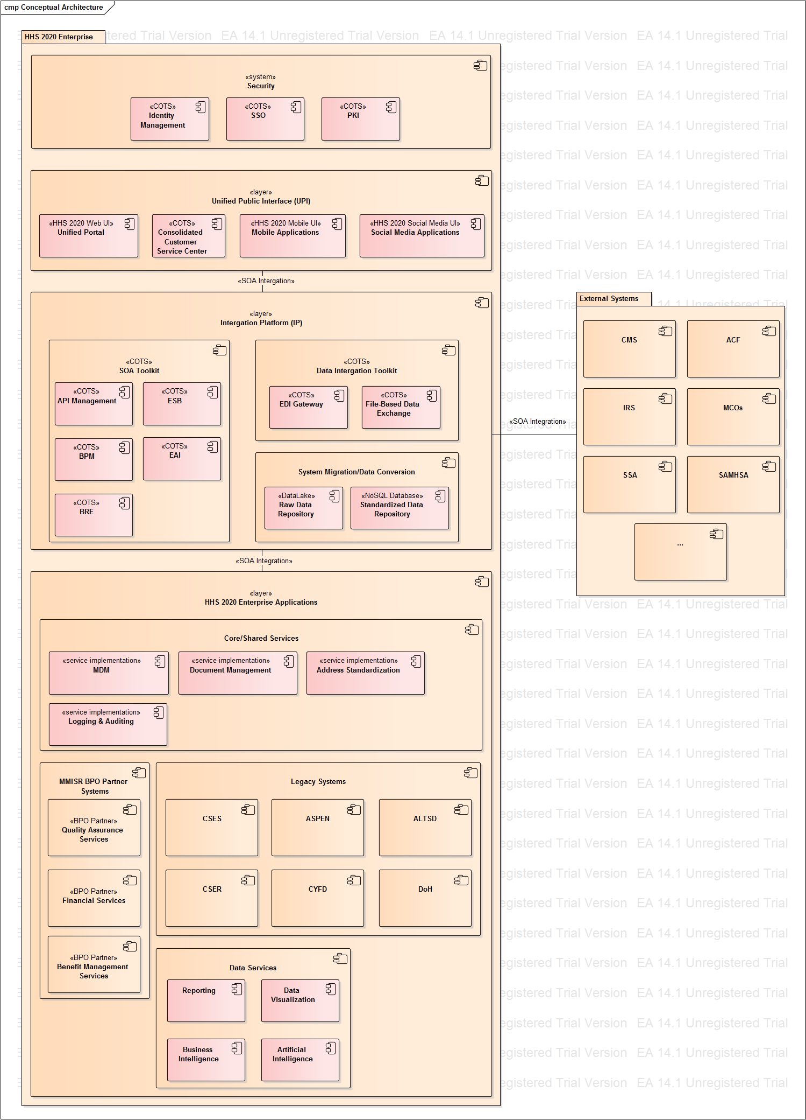
Figure 3: Conceptual Architecture of MMISR
In accordance with HHS 2020 EA standards all software-related architecture views, including the Conceptual Architecture depicted in Figure 3 are modeled in Unified Modeling Language (UML). Diagram 3 shows groupings of components packages comprising both the HHS 2020 Enterprise and the External Systems. SOA integrations are shown as bi-directional associations decorated with the appropriate stereotype. While significant Package and Component Package contents are shown, the package-to-package and component-to-component dependencies are omitted from the conceptual architecture depiction.
The following are the architecturally-significant model elements in Figure 3, above:

Security System
All requests for functionality and data contained within the HHS 2020 Enterprise pass through the Security System. It is comprised of purchased COTS components, configured to meet HHS 2020 requirements for user authentication, role-based access authorization, cryptographic public key infrastructure management and Single Sign-On allowing authenticated HHS 2020 users seamless access to BPO partner and external systems.

Unified Public Interface
The user interface layer of HHS 2020 Enterprise is executed internally as a separate project. The layer includes all human user interaction channels, including Unified Portal (for all external and internal web interfaces and applications), Mobile and Social Media Access (for incorporating mobile devices/interfaces and tying into social media outlets), and a Consolidated Customer Service Center (CCSC)/Call Center Interface (may be available via the Unified Portal, which is TBD).

Integration Platform (IP)
The Integration Platform is the central mechanism for connecting all backend systems, all interfaces to external systems, and users via the Unified Public Interface. The IP layer contains three distinct sub-groupings of functionality.

SOA Toolkit includes Enterprise Service Bus and other service-oriented architecture enablers like COTS EAI adaptors to be used in service implementations, Business Process Management components for process definition and execution, Business Rule Engine to assist in rule-based business processing and context-based message routing through the ESB, and API Management for service discovery and invocation by the UPI layer clients. All systems, subsystems, modules and services will integrate using SOA principles of decoupled services exchanging messages through a common integration platform, briefly listed below:
- Services will be autonomous and decoupled from other services.
- Services will be discoverable through the IP.
- Services will be composable.
- Services will interoperate via sending/receiving asynchronous messages.
- Services and messages will be built to be reusable.
- Services will be stateless and idempotent, as much as possible.
- Services will communicate via asynchronous messages.
- Services will hide their implementation details from other services.
All services will be registered in the API Manager services catalog, which will enforce any policies regarding knowledge of and access to those services. All shared schemas which comprise messages will also be registered in the IP, which will enforce data integrity and Data Quality Management where required. All message requests and responses, except those that may be contained entirely within a BPO partner system, will be managed by the Integration Platform, which will enforce common security protocols to ensure access to the IP and integrity of messages is secure.

Data Integration Toolkit allows for EDI transaction handling and all other ongoing file-based data exchanges in standard (e.g. HL7) and custom formats with HHS 2020 Legacy and external systems.

System Migration Repository (SMR) contains data conversion tooling and intermediate data storage for migrating data from legacy systems (Omnicaid, ASPEN, HSD call center and others) to the new BPO Systems.

HHS 2020 Enterprise Applications
This is a grouping for all new BPO partner applications, services and legacy systems integrated into HHS 2020 Enterprise.

Shared Services are a central resource that will give the Human Services Department’s tools and applications to empower users to work more efficiently and accurately, and eliminate the need for offices to duplicate tools and applications.

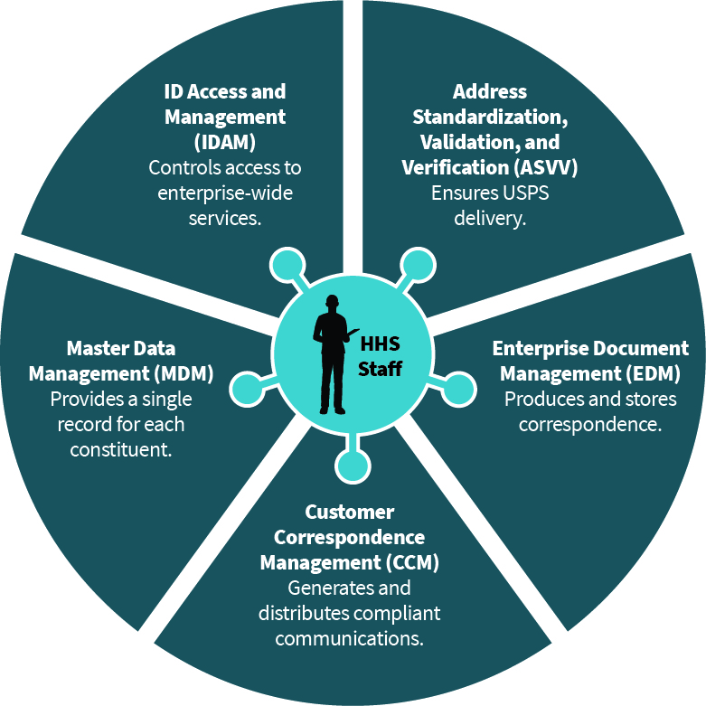
Figure 4: Shared Services Scope

MMISR BPO Partner Systems are component packages procured from BPO Partners which implement distinct business functionality. This consists of all decoupled, stand-alone applications licensed/implemented through the distinct procurements of the MMISR program:
- Quality Assurance Services
- Benefit Management Services
- Financial Services
Each of these modules will rely on tooling procured and implemented via the Systems Integrator procurement, which is responsible for the IP, common SOA tooling Business Process Modeling (BPM), a Business Rules Engine (BRE) and a Workflow solution.

Data Services
A set of data-centric functionalities implemented and operated by a technology partner, IBM Watson Health (formerly known as Truven Health Analytics). The sub-system includes pre-canned and ad hoc report management, data visualization, analysis, business intelligence and artificial intelligence components.

Legacy Systems
This an architectural grouping of systems which exist within HHS and may or may not provide functionality for MMISR. This includes all existing systems that are being operated currently, and which may undergo improvements to increase compliance with the MMISR vision of SOA-enabled integration. System failing to meet desired degree of interoperability at acceptable Total Cost of Ownership (TCO) levels will eventually be deprecated and replaced with architecturally sound alternatives.

External Systems
This is an architectural grouping of all systems which exist outside of NM and may be hosted by other States, by partner organizations (commercial, educational, or other) as well as Federal systems.

Operational/Hosting View of MMISR
The following diagram in Figure 4 depicts how different components of MMISR are decoupled to the degree that they may be hosted, managed and operated in various physical environments, even in different State, vendor and partner data centers, cloud-based systems, and each with separate security zones.

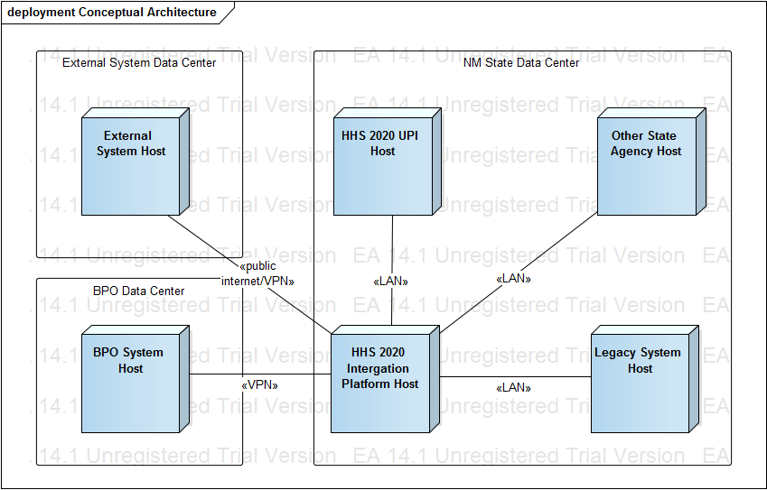
Figure 5: High Level Deployment Architecture of MMISR
The diagram in Figure 5 shows that the design of MMISR assumes that not all systems, subsystems and services will reside in the same data center, as it prepares to leverage cloud-based assets. Some systems will be hosted and administered in different vendors’ data centers, and some will run in the State of New Mexico data centers. They would all integrate and interoperate through a single Integration Platform (IP), which will implement and enforce SOA principles, Data Quality Management verification and validation, security, auditing and logging, as well as host highly reliable and scalable shared services, which will be used by all system assets which are part of MMISR.

The Integration Platform
Figure 6 shows a component static structure depiction of HHS 2020 SOA approach allowing for loose coupling of service consumers form service providers and covering 3 service categories:
- HHS 2020 Shared Services enabled by newly-developed components within the Integration Layer (e.g. Address Standardization, Entity Management, Logging and Auditing etc.)
- HHS 2020 Specialized Business Services enabled by a combination BPO partner and Legacy systems (e.g. Claim, Prior Authorization, Reporting etc.)
- BPO Partner UI Layer Presentation Services proxied for integration into HHS 2020 Unified Portal
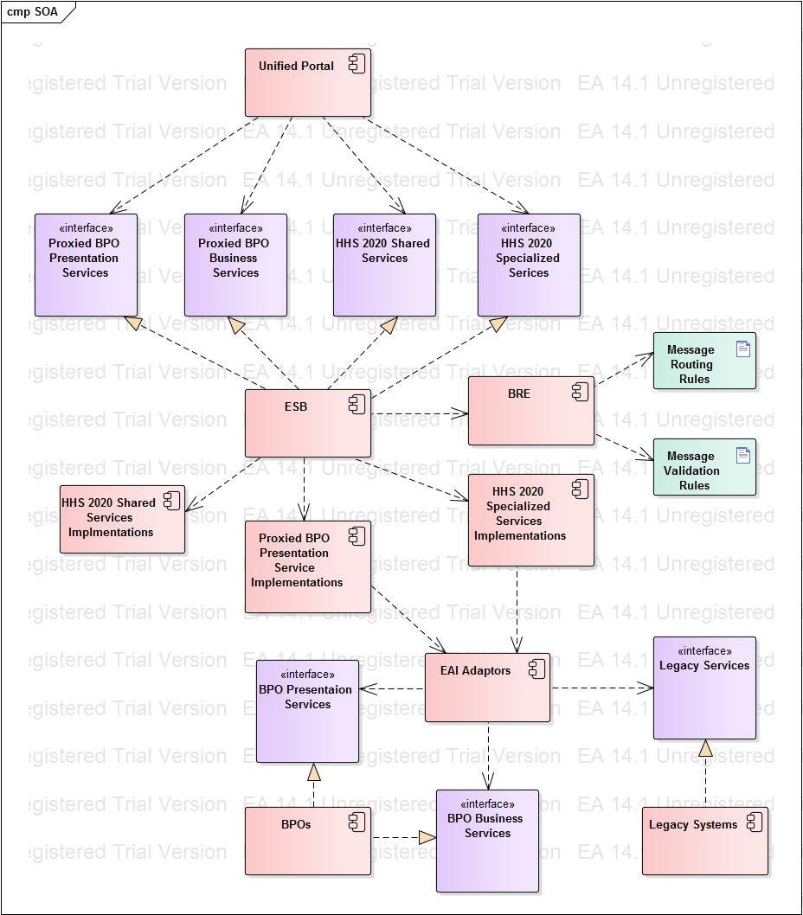
Figure 6: Details on the SOA-Based Design of the MMISR Integration Platform

Role of the ESB
ESB-mediated service invocation is at the core of the HHS 2020 EA’s vision for SOA. ESB is shown in the Implements relationship with respect to all service interfaces. The relationships are justified since all service consumers that are aware of service interfaces (e.g. the HHS 2020 UP supporting human stakeholders or outside systems requesting data from HHS 2020 Enterprise) will request the ESB to invoke the appropriate service end-points rather than having any direct end-point knowledge.
Consumers will communicate with services via messages routed to the appropriate end points by the ESB. Messages will adhere to Shared/Canonical Schemas and validation for both schema and content as well as context-based routing will occur with assistance from a BRE enforcing appropriate sets of message validation and routing business rules. The ESB will provide encoding (XML vs. JSON) and protocol (HTTP vs. JMS) translations to handle messages in a variety of client capabilities. The ESB will enforce role-based authorization for service access and will carry out necessary logging of service interactions for auditing purposes.

Shared Services
Shared services implement shared behavioral (e.g. Reporting, Document Management) and non-behavioral (e.g. Logging, Address Standardization) functional requirements and are intended for broad re-use across business processes. Development of shared services is the responsibility of the SI vendor and all necessary components will reside outside of BPO and Legacy backend systems.
Some of the shared services will rely on the MDM repository of reference data about core business concepts (e.g. Entity Management service will establish relationships among entities and preclude access to information about one entity, e.g. Member by another Entity e.g. State Employee if both entities are part of the same family unit). Others (e.g. Address Standardization) will make calls to external business partners (e.g. USPS, Fair Isaac Corporation etc.) that perform data collection and validation tasks impossible/impractical to perform with HHS 2020 Enterprise. Finally, some impetrations (e.g. Document Management, Communication Management) will enable access to purchased general-purpose COTS systems in a consistent, centralized and mediated fashion.

Specialized Business Services
Data and functionality contained in the HHS 2020 back-end (comprised of externally-hosted BPO partners and integrally-hosted legacy systems) will be exposed via Specialized Business Services. Since the back-end systems integrated via Business services are based on industry-standard technologies (services, web sites, relational databases, file stores etc.) HHS 2020 service implementations will rely primarily on short-running orchestrations of calls though COTS EAI adaptors (e.g. SOAP, REST, HTTP, ODBC etc.) and an assembly of obtained results into canonical schema-based responses.

Presentation Services
Although most HHS 2020 UPI presentation layer functionality will be custom-built as portlets, it is entirely foreseeable that the UPI portal may want to consume data exposed in complete or partial UI pages within the BPO partner systems rather than developing a custom version.
To enable such UI layer integration, HHS 2020 has mandated adherence to Web Services for Remote Portlets or WSRP 2.0 standard for its BPO partner systems. Under this standard, an external portlet acts as a presentation layer service returning both business data in a desired format (XML or JSON) and presentation markup (e.g. lists, pagination etc.) making it easy for the consuming portlet to render the response with minimal additional development effort.
Since HHS 2020 EA does not allow its components to access any service end points (including presentation services) directly, the BPO partner’s services will be proxied by HHS 2020 counterparts hosted on the ESB. Each proxying service will at a minimum make calls to the external portlet via appropriate COTS EAI adaptor and pass the unchanged results to the HHS 2020 clients. We may want to embed additional value-add functionality into the proxy implementations to make results display in the UI pages even easier (e.g. HHS 2020 styling additions).

User Transaction View of MMISR
The most complex set of architectural features found in the HHS 2020 Enterprise is introduced to implement behavioral functional requirements (e.g. use cases or user stories) involving human interactions with the UP layer.
In order to make human user experience most productive and intuitive, the system will take steps to bring to the user only the functionalities permitted under the current context. The context is comprised of multiple criteria, but primarily based on the combination of application roles held by the user which map to three listing of workflows:
- Those that could be initiated by performing a human task
- Those where the user’s participation is required in human tasks of workflows already under way.
- Those that do not participate in any workflows and can be performed at user’s discretion

Static Structure of Participating Components
The following diagram depicts a static structure view of components and interfaces involved in typical realizations of use cases involving human actors.

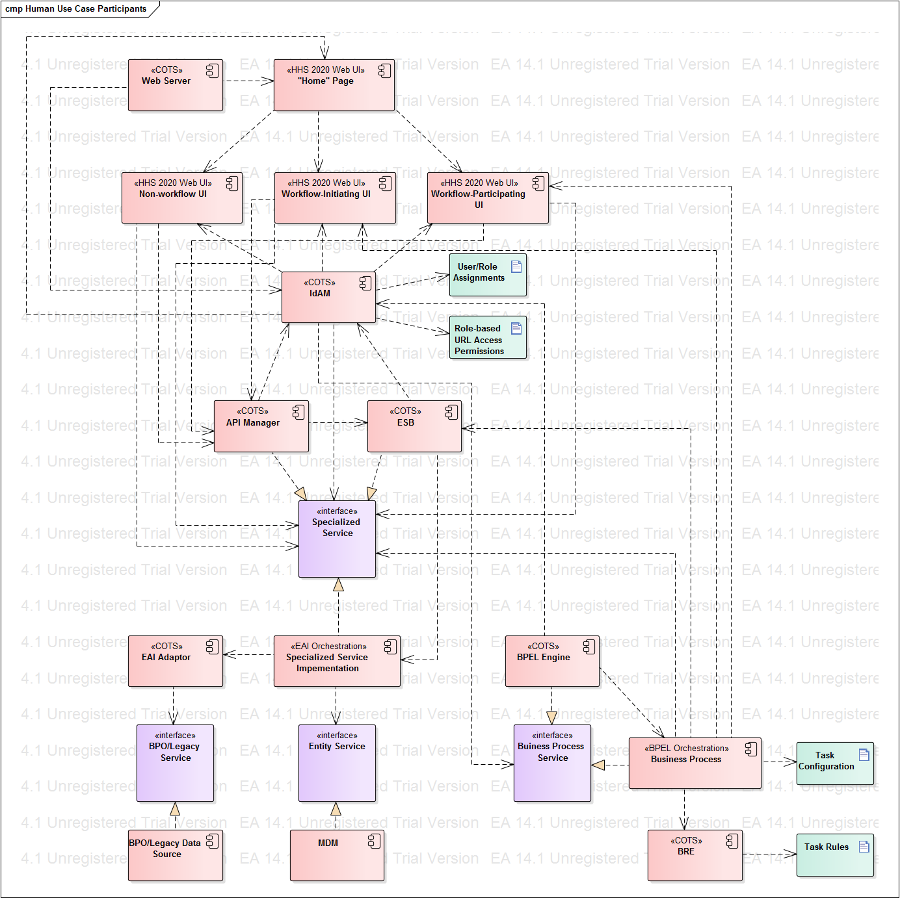
Figure 7: MMISR Architecture Components participating in human use case realizations
Before discussing how the above components collaborate with each other to fulfill use case requirements, we will first introduce each component in terms of its provenance (e.g. COTS, Custom built) and architectural functions.

Table 3: List of Interfaces to MMISR
Component | Provenance | Functions
Web Server | COTS | Web Server hosts Unified Portal and all web pages and portlets. Depends on IdAM to establish user’s ability to access page URLs. Directs user browser requests to appropriate page URLs, starting with the “Home” page.
“Home” Page | Custom built | This is the starting point for authenticated user’s interactions with all other portal pages. (Authentication mechanism, including authentication page is omitted from this discussion since we are focused on interactions of already authenticated users who are represented by a programmatic identity inclusive of application role membership as assigned by IdAM). “Home page” includes mechanisms to access non-workflow enabled, workflow-initiating and workflow participating page URLs permitted to the user based on his/her application role membership.
Non-workflow UI | Custom built | Web pages and portlets to perform non-workflow enabled human tasks at user’s discretion (e.g. content searches, Claim status lookup etc.)
Workflow-Initiating UI | Custom built | Web pages and portlets that initiate workflows configured in the BPEL Engine by performing a human task. Upon task completion the UI informs the initiated business process instance about the outcome (e.g. success vs. failure).
Workflow-Participating UI | Custom built | Web pages and portlets that participate in workflows already running in the BPEL Engine by performing a human task. Upon task completion the UI informs the corresponding business process instance about the outcome (e.g. success vs. failure).
IdAM | COTS | Identity and Access Management system performs multiple security-related functions:  - Defines application roles  - Maintains user assignment to application roles  - Authenticates users and assigns application roles to the identity established during successful authentication  - Monitors access to all URLs (UI pages, business services, business process services) and prevents URL access by users with insufficient application role membership  - Exposes APIs to query for security-related settings (e.g. user’s ability to access a URL)  Being the hub of the security ecosystem, IdAM is dependent upon by numerous components to prevent unauthorized access to URLs:  - Web Server for web pages  - Both API Manager and the ESB for Specialized Services  - BPEL Engine for Business Process Services
API Manager | COTS | API Manager performs functions like the ESB but is intended for clients that reside in front of the firewall which protects the ESB and the rest of the middleware and back-end systems from outside access. API Manager forwards properly authorized requests for services to the ESB and returns responses back to callers. Since API Manager performs ESB-like function it is appropriate to model it as implementing interfaces of all exposed business services. UIs running in the UP layer depend on the API Manager for all service access.
ESB | COTS | ESB provides consistent, role-based access to all HHS 2020 services while providing service end-point location transparency and any necessary message validation, routing, protocol translation and usage/error logging functions.
Specialized Services | Custom built | For current discussion purposes the category of Specialized Services includes all Business and Presentation Services used to implement UI screen and Business Process Service tasks functionalities. All specialized services expose programmatic contracts consumed by their clients while all implementations are hosted in the ESB. Specialized services are constructed as short-running orchestrations making EAI Adaptor-based calls to the programmatic interfaces exposed by the BPO/Legacy Data Sources.
EAI Adaptor | COTS | EAI Adaptors are used by Specialized Service Implementations to make calls to programmatic interfaces exposed by BPO/Legacy Data Sources.
BPO/Legacy Data Sources | Multi-sourced | All back-end systems that serve data of either specialized or presentation service granularities are modelled for illustration purposes as implementing a BPO/Legacy Service interface. The nature of the interface (SOA, language-specific API, WSRP etc.) varies by system and is accounted for during HHS 2020 specialized service implementation through use of the appropriate EAI Adaptor as part of Specialized Service Implementation.
Entity Service | Custom built | Entity service is one of the functions implemented on top of the HHS 2020 MDM solution. Entity Management will establish relationships among entities and preclude access to information about one entity, e.g. Member by another Entity e.g. State Employee if both entities are part of the same household or family unit. Entity Service will be invoked by Specialized Business services as part of additional entitlement checks before returning data to users who would generally be authorized based on the set of held application roles but may be precluded in a specific instance because of the nature of Entities involved.
BPEL Engine | COTS | Business processes subject to automation via HHS 2020 ecosystem are defined and executed via BPEL Engine. Each configured process orchestration is treated by the system as a service with an end-point URL. All process service URLs are registered with IdAM enabling the UI layer functionality of proactively building lists of UI pages that either start services allowed for the current user or require user’s participation in running process instances.
Business Process | Custom built BPEL Orchestration | Individual business processes are implemented as BPEL orchestrations combining the following three types of tasks:  - Human tasks  - Service tasks  - Rule-based tasks  Human tasks are implemented as UIs, including web pages and portlets in the UPI layer. Service tasks make calls to HHS 2020 shared and specialized services via the ESB. Rule-based tasks invoke the BRE to declaratively carry out task-related rule set execution and then proceed according to rule execution outcomes.
BRE | COTS | BRE is used as part of BPEL orchestrations to invoke rule-based task rule sets and to return rule execution outcomes to business process orchestrations.

Participating Components Interaction Sequence
The following sub-sections describe interactions among the components listed above necessary to achieve five demonstrated capabilities:
- Build-up of “Home” page with links to permitted pages
- Invocation of Non-workflow functionalities
- Invocation of Workflow-initiating functionalities
- Invocation of Workflow-participating functionalities
- Performance of Entity-level authorization checks during functionality invocation

PLEASE NOTE: The diagrams depict conceptual component-to-component interactions. Actual sequences of method calls across technology-specific implementations (e.g. Liferay Portal, Oracle IdM etc.) have much greater detail reflecting each participating object’s programmatic interfaces.

“Home” Page Creation
The following sequence assumes that the user is authenticated and has role membership allowing for access to “Home” page.
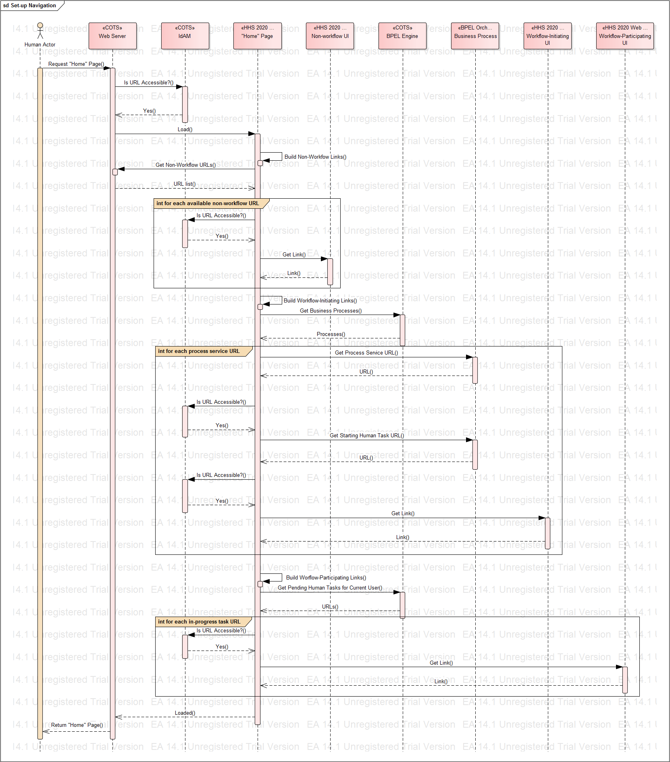
Figure 8: Illustrative “Home” Page creation Component interaction sequence
- The Actor requests the “Home” page from the Web Server.
- Web server queries the IdAM and determines that requested URL is accessible to the Actor.
- Web Server loads the “Home” page.
While loading the “Home” page first builds non-workflow page links.
- “Home” page requests from Web Server the list of non-workflow page URLs.

Steps 6-7 are repeated for each returned non-workflow URL
- “Home” page queries IdAM and determines that non-workflow URL is accessible to the Actor.
- “Home” page creates a navigation link for the non-workflow URL.

“Home” page proceeds to render workflow-initiating page links.
- “Home” page requests the list of business processes from the BPEL Engine.

Steps 8-10 are repeated for each returned business process
- “Home” page queries the Process for the URL of the initiating human task.
- “Home” page queries IdAM and determines that initiating task URL is accessible to the Actor.
- “Home” page creates a navigation link for the task-initiating URL.

“Home” page proceeds to render workflow-participating page links.
- “Home” page requests the list of pending human task URLs from the BPEL Engine.

Steps 12-13 are repeated for each returned pending task URL
- “Home” page queries IdAM and determines that initiating task URL is accessible to the Actor.
- “Home” page creates a navigation link for the task-participating URL.

The completed “Home” page is returned from the Web Server to the Actor and ready for interaction.

Non-workflow Page Invocation
The following assumptions are made in the sequence below:
- User is authenticated and has role membership allowing for access to “Home” and non-workflow page.
- “Home” page has been initialized and includes a link to non-workflow page.
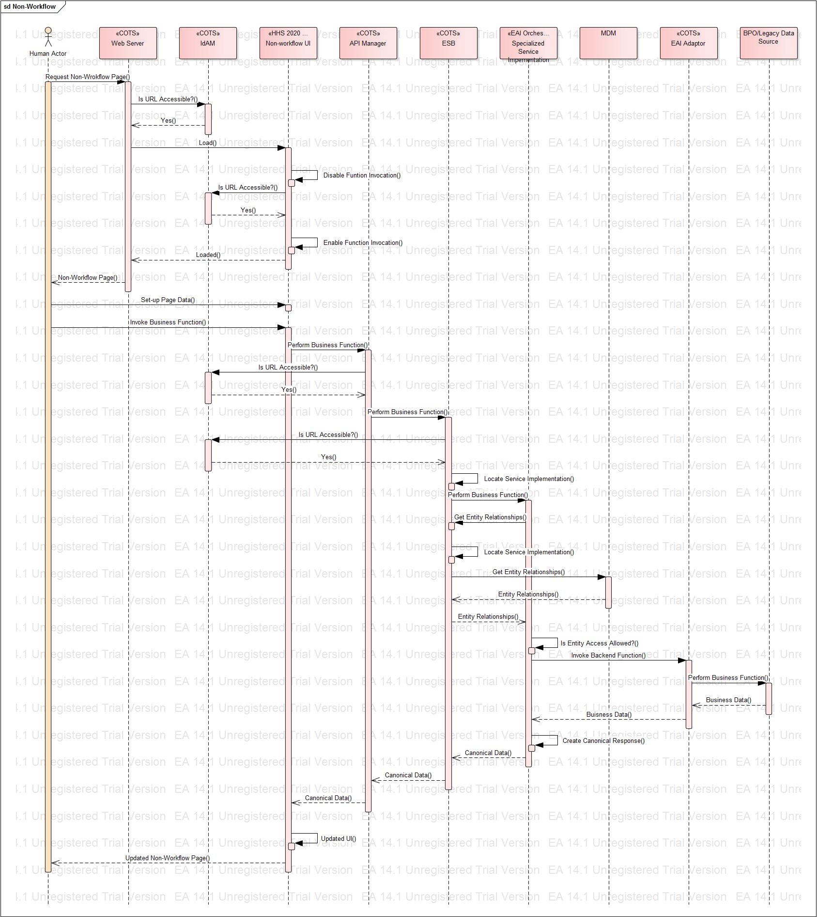
Figure 9: Illustrative Non-Workflow Page Invocation Component interaction sequence
- The Actor requests a non-workflow page from the Web Server.
- Web server queries the IdAM and determines that requested URL is accessible to the Actor.
- Web Server loads the non-workflow page.
- The non-workflow page contains a mechanism to perform a business function (e.g. a button to retrieve a claim based on entered criteria). The implementation of the page assumes that the current actor is not permitted to perform the business function and disables the invocation mechanism (e.g. a button is disabled and grayed out) by default.
- Page implementation queries the IdAM for actor’s ability to access the service URL of the business service that would be invoked from the page if the invocation mechanism were enabled (e.g. Get Claim Service) and determines that access to the service is permitted.
- Page implementation enables the invocation mechanism since the user is entitled to access the service based on the combination of application roles and permissions assigned in IdAM.
- The initially-rendered page is returned to the Actor.
- The Actor interacts with the page UI and sets-up necessary data to invoke the business function (e.g. specifies which Claim is to be shown by providing Claim ID).
- The Actor invokes the business function on the page (e.g. clicks the button).
- Page implementation makes the call to the API manager to invoke the appropriate service to perform the business function.
- API Manager determines that current user is entitled to invoke the service and forwards the request to the ESB.
- ESB queries the IdAM for actor’s ability to access the service URL of the business service and determines that access to the service is permitted.
- ESB locates service implementation end-point and makes the call to the specialized service implementation component (e.g. Get Claim Service).
- Specialized service implementation determines that the service can only be invoked if there is no conflict of interest between the Entity representing the Actor (e.g. State Employee) and the Entity to whom the requested Claim applies (e.g. Medicaid Member). Should both Entities be part of the same family unit or reside in the same address, the conflict of interest should prevent the Actor from seeing data for the requested claim.
- Specialized Service Implementation calls the ESB to invoke the Entity Management Service (implemented by the MDM solution) to get the relationships among entities involved in the requested business function.
- ESB determines the end-point location for the Entity Service and forwards the request.
- MDM solution generates a representation of relationships among requested entities and returns the data to the ESB, which returns relationship data back to the specialized service implementation.
- Specialized service implementation determines that the Actor is permitted to access the requested Entity data as no conflict of interest exists.
- Specialized service implementation uses an appropriate EDI Adaptor (e.g. ODBC, JMS, CICS, SOA etc.) to make the call to the Backend/Legacy system that hold requested data and/or performs requested business function.
- The backend system performs the requested function and returns data to the EAI Adaptor, which, in turn, return data back to the specialized service implementation.
- Backend data is transformed into canonical message model and returned all the way back to the non-workflow UI page.
- The page renders necessary updates to the UI and returns to the Actor for subsequent interactions.

Workflow (Initiating/Participating) Page Invocation
The following assumptions are made in the sequence below:
- User is authenticated and has role membership allowing for access to “Home” and the workflow page.
- “Home” page has been initialized and includes a link to workflow page.
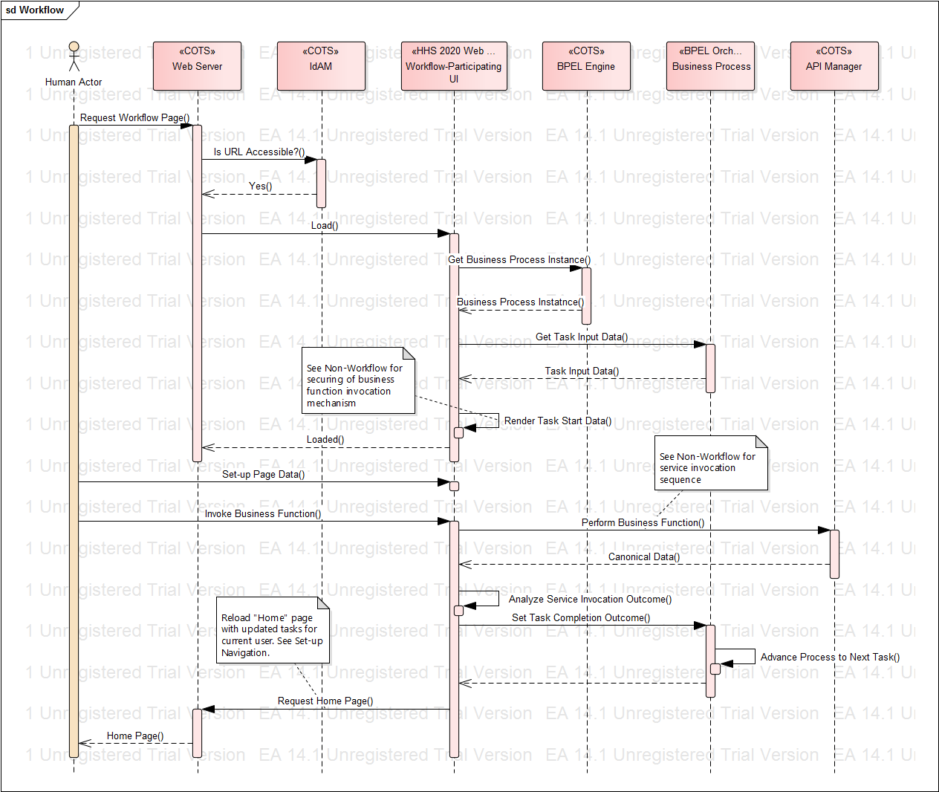
Figure 10: Illustrative Workflow (Initiating/Participating) Page Invocation Component interaction sequence
- The Actor requests a workflow page from the Web Server.
- Web server queries the IdAM and determines that requested URL is accessible to the Actor.
- Web Server loads the workflow page.
- Workflow page implementation contacts BPEL Engine for the corresponding Business Process instance and queries the Process instance for the data to be used as an input to the current human task.
- Workflow page renders start-up data for the task and secures the business function invocation mechanism based on user’s application role membership (see Non-Workflow Page Invocation for description).
- A properly initialized workflow page is returned to the Actor.
- The Actor manipulates the data in the page and requests invocation of a business function that would cause data to process (see Non-Workflow Page Invocation for details on business function invocation via a specialized service).
- Once canonical data is returned from the business service a decision is made in the implementation of the page about the task completion status (e.g. success vs. failure) and the status is communicated to the Business Process instance causing the process to advance to the next step.
- Since the current page’s work is finished the system navigates the user back to the “Home” page which is rebuilt with updated workflow page links reflective of the next steps in various workflows applicable to the current user (see Set Up Navigation for workflow page link generation details).

Data Conversion Architecture – The System Migration Repository (SMR)
This view of architecture in Figure 11 below, shows how data would be extracted from source/legacy systems, transformed, cleansed, converted to a new schema, and loaded into tables that enforce and validate NM HHS data governance policies for data quality management.
This would all occur within and through the System Migration Repository (SMR), which is under construction by the SI Vendor for MMISR. The purpose of the SMR is to create a reusable infrastructure with repeatable policies, processes and data quality management (DQM) best practices for all systems that wish to integrate with MMISR assets.
Described more fully in the Data Conversion Plan, this reusable platform is meant to assist in the conversion of legacy data into various MMISR systems, for an initial load or incremental batch load scenarios.
The SMR is not meant to supply operational, transactional data to MMISR systems in real time. It is only meant to perform bulk loads of source data into MMISR systems. All transactional data, once the system/module is live, will be populated by transactions flowing through the Integration Platform.
The SMR is a reusable platform that includes ETL tooling, Data Quality Management (DQM) tooling, databases, data modeling, and data dictionary tools. It is also a main asset used by the NM HHS Data Governance Council for publishing policies on shared data, shared schemas, data models, data security, and other data sharing/reuse topics.
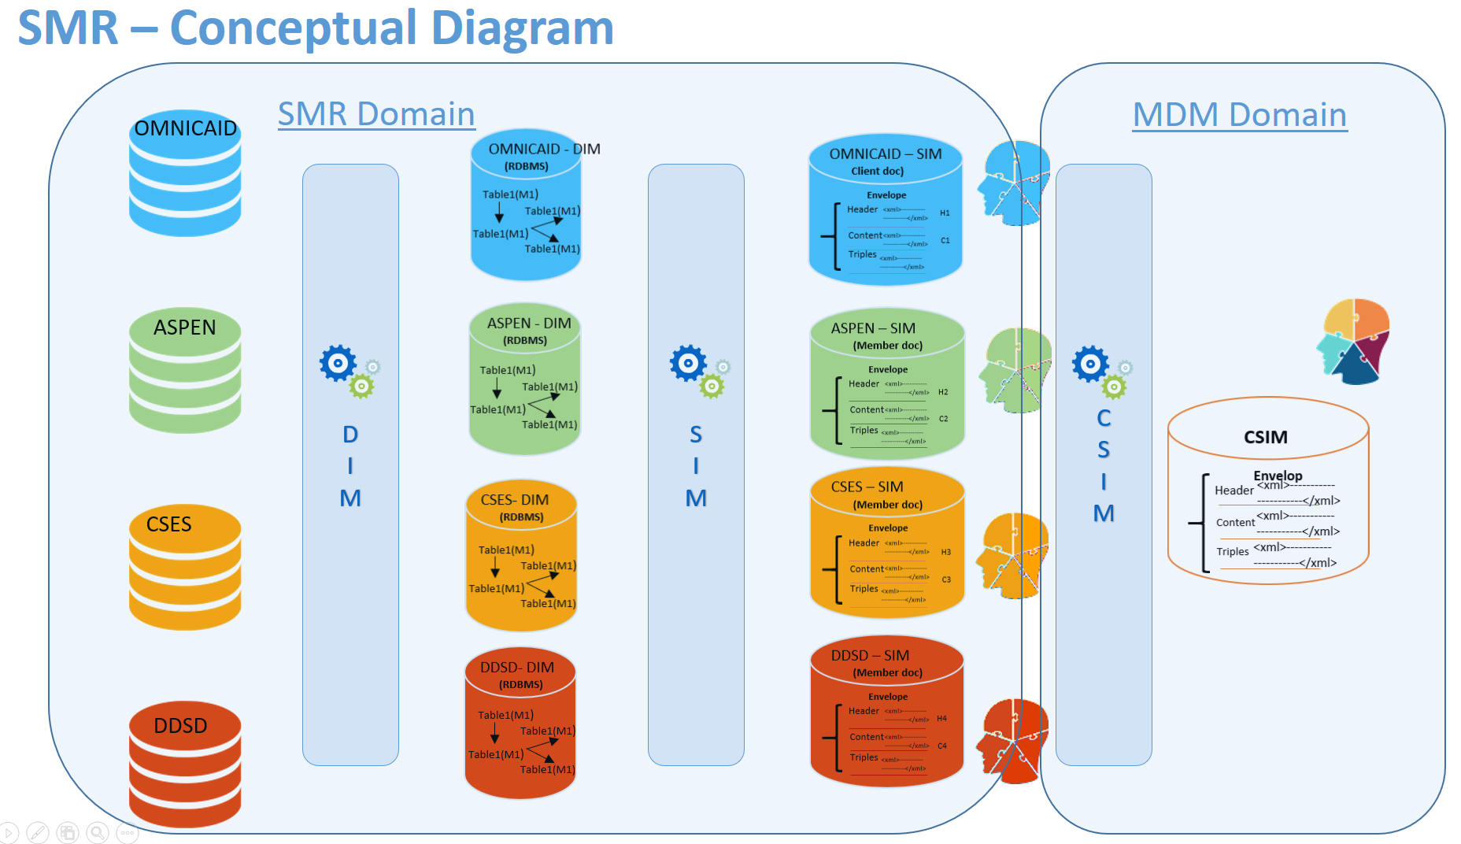
Figure 11: SMR Design

Figure 12 below illustrates the SMR-enabled data migration process.

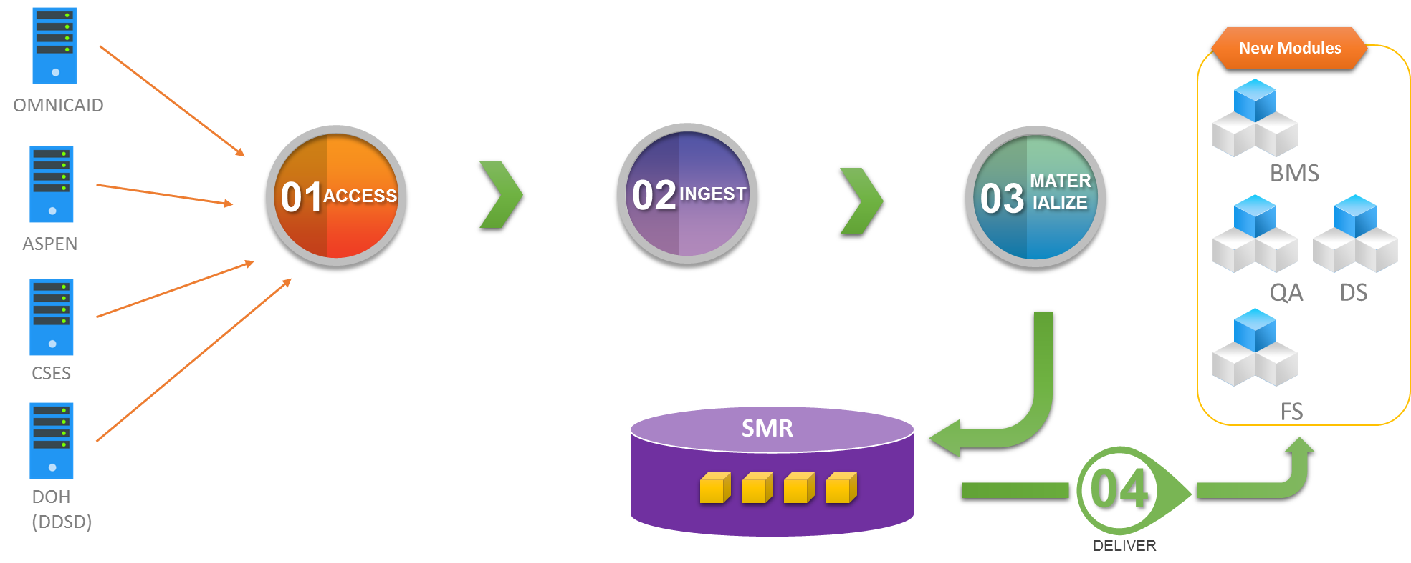
Figure 12: Pre-Go-live Data Integration Steps
Migration of a given legacy system to a new BPO vendor operation would proceed as follows:
- A copy of the legacy system’s data in complete raw form will be obtained.
- Complete raw legacy data set will be placed into a data lake repository.
- Convert the raw data into canonical format, standardize reference values and enhance data quality through de-duplication.
- Place canonical, standardized and de-duplicated data into the NoSQL database of the System Migration Repository.
- Make NoSQL database contents available for ingestion by new BPO Partner systems to enable their operation within HHS 2020 Enterprise post go-live.

High-Level Operational Requirements and Characteristics
As stated earlier in this document, the mission of HSD is to reduce the impact of poverty on people living in New Mexico by providing support services that help individuals and families break the cycle of dependency on public assistance. MMISR is an initiative that has been undertaken to redesign business processes and replace existing technology systems in order to improve the efficiency and effectiveness of the delivery of services to New Mexicans. The objectives of MMISR are as follows:
- Enhance the ability to operate in a dynamic environment with increasingly restricted funding with increased service quality levels;
- Provide greater flexibility to take advantage of rapidly evolving technology to achieve service improvements and/or to reduce maintenance and operation costs;
- Provide increased ability to respond promptly and insightfully to changing program or population needs;
- Support an outcomes-based approach to planning, delivering and assessing service delivery – focusing on the end impact and value to New Mexico citizens instead of on internal processing requirements;
- Reduce redundancy through enterprise-wide sharing of technology, services, data and processes to deliver high-quality customer service; and
- Achieve the realization of a customer-focused approach to service management and delivery that can make it easier for New Mexico citizens to understand and receive needed services and for providers to interact with the State.
To this end, the goal for all new systems is to adhere to the commonly-used MMISR architecture (for all shared services and reused MMISR components), common technical requirements, expanded capabilities, common governance and cross-program functionality. The State will leverage enterprise architecture, technology platforms and acquired service capacity for multiple business needs across programs and across human service agencies, including HSD, DOH, CYFD, ALTSD and other HHS departments.
This integrated enterprise technology and services approach will:
- Provide a one-stop access point to support a person-centric model beginning with initial contact or outreach with citizens (e.g., Program Socialization, Information Sharing, Exploration, etc.) through benefit coordination and reconciliation.
- Support integrated user access, robust self-service for eligibility application and determination, and enhanced service delivery and case management coordination across State programs.
- Improve experiences and outcomes for internal and external Stakeholders, including “one stop shop” access to Enterprise services, improved data analytics and business intelligence, and enhanced population health and self-sufficiency outcomes.
- Enable faster creation of applications through the use of modern Business Process Management, Workflow, Orchestration and Business Rules tools.
- Establish and Leverage the agility and adaptability of a service-oriented architecture (SOA) to more easily share data and build composite applications.
- Provide for improved enterprise data quality, accuracy, timeliness and results.
- Establish master client, master provider and master employer indices.
- Build an integrated business intelligence solution (Data Services) that facilitates shared and cross-program information sharing.
- Bring reporting, analytic and business intelligence tools to enterprise users.
- Implement a shared services approach that can provide common technology components and capabilities to support information integration and exchange shared analytics to enhance decision support and performance measurement at all levels.

User Community Description
The user community for the new Enterprise MMIS includes all the Human Services Department Divisions (MAD, ISD, CSED, BHSD, ASD, OIG, ITD) and other agencies- DOH, ALTSD, CYFD, Providers, MCO’s, and Clients.

Non-Functional Requirements
The following are high level non-functional requirements for MMISR:
- The MMISR system will enable HHS department management to modernize operations and dramatically increase organizational flexibility,
- The MMISR system will promote the alignment and improved efficiencies of similar organizational/business functions,
- The MMISR system will provide a “single front door” to all NM residents who need HHS departments’ services via a single Unified Portal,
- The MMISR system will implement a service-oriented architecture to promote flexible, extensible integration of disparate, decoupled systems,
- The MMISR system will promote reuse of IT assets within and outside HHS organizations and systems,
- The MMISR system will institute new practices of governance to manage shared data, common/shared objectives, and shared assets,
- The MMISR system will consolidate all security enforcement mechanisms for Identity and Access Management, as well as securing messages through the Integration Platform.

Decoupled and Autonomous Systems
NM MMIS agencies, departments, divisions and bureaus will continuously evolve how they conduct business, the changes in organizational design and interfaces to various entities (physical locations as well as electronic interfaces) will need to evolve constantly. As the mode of contacting consumers changes to more fully take advantage of mobile technology and the Internet of Things (IoT), the underlying systems and architecture will need to anticipate those changes to enable and fuel the changes that the business needs to make. Therefore, the MMISR architecture promotes systems that support changing business operations, that may exist in changing and even mobile business locations and result in or promote evolving business practices.
BPO vendors’ systems are delivered as independent applications that interoperate through an ESB, using the SOA design principle for autonomous, decoupled services.
In order to be able to connect and (re)configure systems with minimal operational impact, a SOA approach was determined by both CMS and NM to be the best architectural design style. However, ensuring that services are truly independent and decoupled requires more than just implementing web services and an ESB. In order to get separate interoperable services that are independently scalable and maintainable, service designs will ensure they are autonomous, taking on a defensive posture in ensuring the integrity of each service. It also requires that the services be decoupled, only interoperating through contracts and via reusable, independent, standards-based schemas.
For BPO vendors who are implementing a COTS product, they must conform to service interfaces that strive for autonomy but must implement decoupling and integration via standardized messages and schemas.

Vendor-Borne Operational Responsibility
New Mexico HSD does not wish to create and operate all the systems that will make up the MMISR ecosystem, nor the MMIS system itself. Instead, it is the desire to outsource many of the systems components where feasible, and when approved by the New Mexico Department of IT (DoIT). Therefore, vendors will be relied on to not only deliver operationally robust systems, they will, in most cases, be required to run, manage, tune and maintain their components. Some aspects of MMISR will be shared, such as the Customer Support Center, and the call tree for problem determination, assignment and resolution will involve a third-party call center application that will involve all MMISR vendors, who will ultimately solve customers’ and users’ issues.

Operational Risks Spread Over Multiple Vendors’ Environments
By employing a decentralization and loose-coupling strategy among vendor solutions, operational risks, issues, and failures are distributed and there will not be a single point of failure. By following rigorous SOA design principles, these failures will be isolated to only those system components which are under duress. The overall reliability of MMISR will be vastly improved and overall brittleness will be reduced dramatically.

Hosting Transparency
To further enable the vendors’ independence, the HSD Information Technology Department (ITD), which is designing and using the MMISR architecture, is allowing each vendor to host their solutions on whatever platform and in whatever data center/facility they wish, as long as they can meet security requirements, service level agreement objectives, reliability objectives, maintenance window objectives and other measurable criteria. ITD will be using similar criteria as a customer would use to gauge the efficacy and reliability of any cloud solution to measure vendors’ levels of service availability, security, and quality.

Security and Privacy Considerations
Several of the MMISR system components will store Personal Health Information (PHI) and/or Personally Identifiable Information (PII). Additionally, those data may be transferred outside of the MMISR ecosystem boundaries, to various partners, Providers, payors, and Federal agencies such as CMS, IRS and SSA.
Therefore, security requirements will be appropriately stringent across the entire MMISR system and at all integration points, whether through portals, or in file sharing sites for EDI and FTP transfers. As those data may at any time be in transit between disparate vendor facilities and system modules/subsystems/components, security and privacy enforcement are paramount.
For end user access, whether state employee, contractors, end users, or those operating on behalf of end users, the security requirements for establishing and safeguarding their login and identities must be strictly enforced. Single Sign-on will be a requirement for all users, and if state workers are working remotely, provisions for VPN or other security safeguards will be specified, implemented, monitored and audited.

Availability Requirements
Each business process may require different availability and reliability. For State workers, systems will be available for a window of time before, during and after typical work days. The same may apply to partners, who follow standard business hours. However, others may require more availability.
For all the shared services, the Integration Platform and all the modules of the MMISR ecosystem, those components should be available at least 99.99% of the time, if not 99.999%, to ensure that users who wish to interact with MMISR at any time of the night or day are able to do so.
Similarly, each subsystem may have distinct reliability requirements that dictate how often a system may be allowed to become inoperable.
The System Integrator will provider Disaster Recovery services and support to provide an automated fail over to a remote data center where production services will continue with very little interruption. The System Integrator will provide these services in a manner to accomplish the HSD Recovery Point Objective of 15 minutes and a Recovery Time Objective of 60 minutes.

Volume and Performance Expectations
Table 4: MMISR Transaction Estimates
MMISR System Name | Average Daily Manual Transactions | Average Daily Batch Feeds | Peak Periodic Transactions | Peak Period Duration | Peak Period Frequency
Financial Services | 100-500 transactions | 1-10 batch feeds;  100-500 mb file size | 500-750 transactions | 1 Day | Monthly (end of month)
Quality Assurance | 50-250 transactions | 1-10 batch feeds;  100-500 mb file size | 250-500 transactions | 1 Day | Quarterly (end of quarter)
Benefit Management Services | 100-500 transactions | 1-10 batch feeds;  100-500 mb file size | 500-750 transactions | 1 Day | Quarterly (end of quarter)
Consolidated Customer Service Center | 500-1,000 transactions | 1-10 batch feeds;  100-500 mb file size | 1,000-2,500 transactions | 2 Days | Occasionally
Unified Portal | 5,000-10,000 transactions | No batch feeds | 15,000-20,000 transactions | 3 Day | Occasionally
Data Services | 500-1,000 transactions | 500-1,000 messages;  2.5 mb message size; | 5,000-10,000 messages | 1 Day | Occasionally
Integration  Platform | No manual transactions | 150,000-500,000 messages | 1,500,000 transactions | 1 Day | Occasionally

High Level Architecture And Alternative Analysis
Figure 13 is the “dependency diagram” for the MMISR Technology Architecture. This is the most precise, rigorous definition of the sets of technologies that will comprise MMISR.
Figure 13: MMISR Technology Architecture
It differentiates between groups of technologies that have certain aspects in common (these are grouped into several architectural “domains”), and those that are different (belong to different domains). This allows concentration of designs and the skills required to design, develop, integrate, test, implement, extend and operate different kinds of technologies: the embodiment of an architectural principle of “singularity of purpose” at a human resource level. This model is a deliverable of the MMISR Technology Architecture.
This is a “dependency” diagram, showing which domains are developed in context of other domains. Generally, the domains in the lower levels influence and constrain design, tooling and development activities in higher domains. For example, a user interface element does not decide on service definitions, DB selections and design, nor hosting platform. It is developed in dependency on the coarse-grained or fine-grained services which will enable it to complete its task. Similarly, a coarse-grained service does not define the lower level, atomic services it needs. Instead, it reuses and is dependent upon the lower level service definitions. Similarly, these services do not decide messaging standards and designs; they reuse what was determined, designed and managed by the lower level Integration Platform architectural domain.
This architectural model builds upon two foundational Enterprise Architectural domains: The Information Architecture and the Business Architecture domains. Both of these are distinct development efforts that will influence the MMISR program, but since they should inform, influence, constrain and guide the development of all software and data artifacts, they are shown as the most foundational architectural domains, which the rest of the MMISR technology stack will implement.
Figure 13 shows the sub-architectures that comprise MMISR. Similar to Figure 3, this figure shows where certain system components “fit” and how system assets with similar responsibilities are grouped together. It also shows the interdependencies between domains (and types of products contained in each domain). This diagram defines architectural domains that are responsible for specific kinds of functionality. It also shows that Governance is required for all architectural, design, development, integration, testing, delivery and operational activity. It is a “peer” domain, not specifically dependent upon any other, nor imposing itself as a dependency upon any of the technology architectures.
The following briefly defines the purpose and purview of each of the architectural domains depicted in Figure 13, starting at the most foundational level and working upwards.

Information Architecture
Responsible for the specification of Information Architecture (IA) artifacts, models, repositories, etc. that portray and define the things of interest to MMISR; those may be subject areas, entities, classes, objects, attributes, relationships; each IA artifact establishes specific terms and definitions that the rest of MMISR systems are built on; specifically, all messages, data transfer files, and service contracts will use these terms to create reusable message schemas; DBAs will use these terms and schemas to construct logical and physical schemas; user experience designers will use these terms to construct user interface objects. This architectural domain works hand-in-hand with Data Governance to create and publish principles of data management, policies for sharing, definitions of data quality, processes and business rules for data quality management, and may task data stewards to actively monitor and improve the quality of shared data.

Business Architecture
Responsible for the specification of all business areas, categories and grouping of processes, decompositions of processes, definitions of Business Process Management (BPM) processes, definitions of workflow processes, and definitions of services implemented as software that work together to accomplish myriad MMISR goals, objectives and missions; each of these processes are defined explicitly and show triggers, data consumed & produced, and other actions that may result from the execution of the process; many of the processes will be implemented as services (coarse-grained or atomic), modules, and systems within MMISR.

Infrastructure Architecture
Responsible for defining the platforms, standards for Operating Systems, Database Management Systems, Middleware, Networking, Security, applications and other network and operations components; responsible for specifying standards and expectations for business continuity planning, system failover, backup and recovery; responsible for specifying decision-making processes for hardware and software approval and exception-granting policies for platforms outside the direct control of ITD; responsible for measuring, testing, assessing and reporting on security (at all levels) for all platforms and systems; responsible for specifying standards/criteria/requirements for SaaS, PaaS and cloud computing; responsible for setting standards for system monitoring and controls, regardless of where system assets are hosted.

Integration Platform Architecture
Responsible for setting standards for implementing SOA across multiple platforms, solutions, systems, and services; establishes standards and guidelines for integrating systems utilizing SOA design and implementation principles and tooling; hosts all tools required to allow services and systems to integrate via the exchange of messages (BPM, BRE, Workflow engines); actively manages service invocations and message exchanges in accordance with service contracts and policies; implement common auditing, logging, security, event management, data quality and other cross-cutting concerns; implement all core functions of Enterprise Service Bus (ESB) and patterns of enterprise integration; implement a Systems Migration Repository (SMR) containing ETL/ELT tooling, data dictionaries/metadata repositories, staging databases, data quality management and producing high quality data to systems being created/populated within the MMISR ecosystem.

Fine-Grained/Core Services Architecture
Responsible for standards, guidelines, recommendations, policies, procedures and governance for all services, created according to MMISR SOA principles and processes, ensuring adherence to software design principles (separation of concerns, autonomy, loose coupling, etc.); responsible for mapping service definitions to Business Architecture designs, models and other artifacts, as well as mapping of messages with BA artifacts; implements Service Governance to oversee the evolution of all services; enforces standards on service definitions, integration patterns, service contracts; enforces adherence to Information Architecture specifications on data schemas, adhering to Federal and State guidelines for reusable schemas (NIEMS, HL7, others); approves the definition of services from MMISR vendors who will implement parts of the ecosystem; oversees implementation of core services and other highly reusable services; approves scalability and availability designs for services.

Legacy Systems & HHS Systems Architecture
Contains all legacy systems; helps determine options for making them more SOA-compliant; makes recommendations on options for replacing, upgrading, or otherwise evolving the systems; strives to enforce SOA design principles, defined within the Integration Architecture.

Coarse-Grained Services/Composite Applications Architecture
Responsible for specifying the designs of all coarse-grained services and/or composite applications; responsible for mapping all service definitions/contracts and shared schemas/message designs to Business Architecture designs, models and other artifacts; enforces proper use of BPM, Workflow and BRE tooling provided by Integration Architecture; responsible for high quality interfaces to COTS or other packaged systems that will implement various business processes.

User Experience Architecture
Responsible for standards of all types of user experience mechanisms, including Portals, browsers (publishes version compatibility), legacy, non-browser interfaces; specifies the integration of mobile device tooling/capabilities as user experience devices, including recommendations on use of mobile applications, mobile platforms, mobile tooling, security, integration patterns that go beyond the simple use of mobile browsers; responsible for setting long-term goals for evolving user experience to achieve fluidity, continuity, ease of use, security, effectiveness etc. across all platforms a user may wish to use.

Governance
Responsible for ensuring all standards, specifications, principles, policies, rules, processes, decision-making, prioritization, approval, dissemination and enforcement mechanisms are in place for Data Governance, Service Governance, Security Governance, Architecture Governance and other types of governance, as necessary.

Application Architecture
Table 5: MMISR Application Architecture
Application Component | Type (Identify both – (1) Operational or Analytical, (2) Batch or Online?) | Strategy (Build, Buy, Reuse, Rewrite) | Alternatives | Pros | Cons | Preferred Alternative
Financial Services | Operational, Online | Buy | None | none | none | none
Quality Assurance | Operational, Online | Buy | Implement in stages or subsystems | none | none | none
Benefit Management Services | Operational, Online | Buy | Implement in stages of subsystems | none | none | none
Data Services | Operational, Online | Build | Implement in stages | none | none | none
Unified Portal | Operational, Online | Build | none | none | none | none
Integration Platform | Operational, Online | Build | none | none | none | none

Information Architecture
NM MMISR Information Architecture (IA) is put forth in support of five major objectives:
- To bridge gaps in data quality and consistency that exist amongst the disparate systems holding information in the legacy NM MMIS.
- To enable cutover of legacy functionalities to the new BPO module modules with standardized subsets of data pertinent to each module’s operational needs.
- To provide a system of record for informational concepts maintained across different systems.
- To support file-based data exchanges between the HHS 2020 enterprise and outside entities.
- To enable improved data reporting and newly-introduced business intelligence functionalities.

The role of the HHS 2020 IA is bounded by the requirements for reporting, data analytics, artificial intelligence-based data pattern discovery and exposure of numerous information architecture components as services to the enterprise. The proposed enterprise Information Architecture is based on the modern Big Data Factory approach depicted in Figure 14 below.
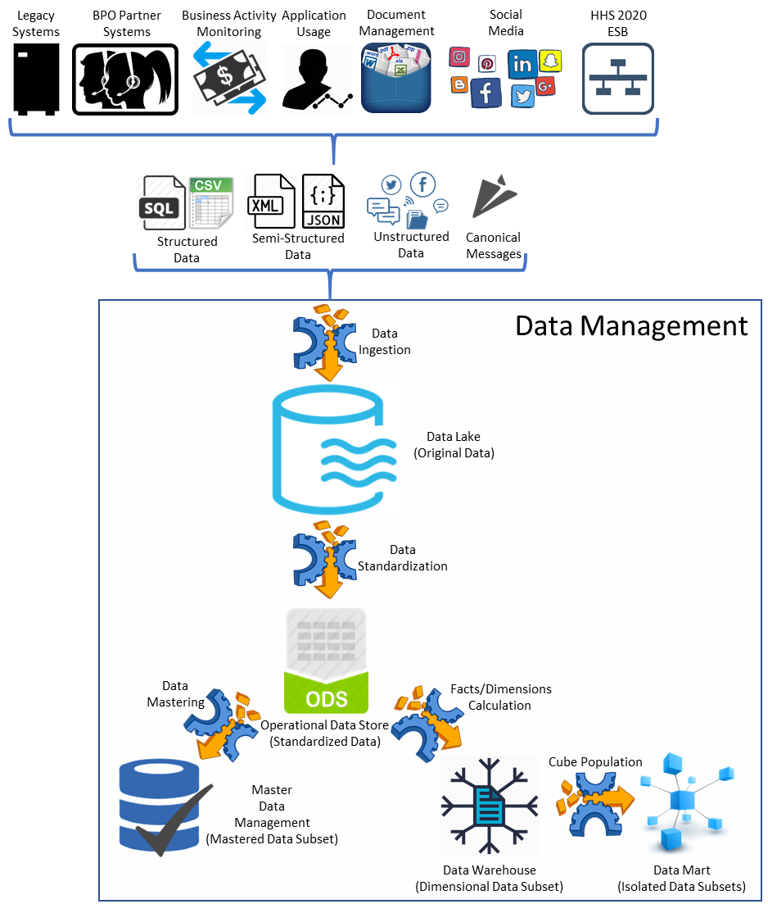
Figure 14: NM MMISR IA Data Factory
Data Types and Sources
The HHS 2020 Data Factory will routinely ingest data from a variety of sources. Data of interest falls into four categories:
- Structured – strongly structured and consistent data extracts from application back-ends (e.g., SQL exports, delimited files)
- Semi-structured – data with applied schema but no guaranteed consistency (e.g., XML and JSON-encoded files)
- Unstructured – data in formatted document files, free-form text, images, etc.
- Canonical Messages – information exchanged among HHS 2020 services. Although messages follow XML encoding (like semi-structured data) their content is consistent with applicable rules, making them more akin to structured data.

The likely data sources of each of the above categories are:
- Legacy systems primarily supplying batch extracts of structured data with a possibility of messages sent from applications that have been enhanced with SOA capabilities for HHS 2020 ecosystem participation.
- BPO module systems will deliver a mix of structured data extracts and canonical messages.
- Metadata about execution of business process orchestrations and application usage of HHS 2020 presentation layer components will be delivered as a combination of structured data extracts and semi-structured files.
- Documents residing in the enterprise document management system, digital content assets deployed via the Liferay digital experience platform and social media content and metadata for interactions of interest to NM HSD will be represented as unstructured data.
- HHS 2020 data back-end will subscribe to certain canonical messages from the ESB that are deemed applicable to enterprise data management capabilities.

Data Ingestion and Data Lake
All data entering the data management boundary will be stored within a data lake. The data lake will preserve all incoming data and metadata details and make them available for subsequent refinement as an input into the artificial intelligence sub-system for machine-driven pattern analysis. The data lake will be built in COTS technology from MarkLogic.

Data Standardization and Operational Data Store
The transactional sub-set of raw data will be transformed into an operational data store. In the steady state, the HHS 2020 enterprise will contain transactional data at stipulated quality levels (e.g., error rates and extent of duplication below maximums permitted under HSD data governance quality standards), reducing the need for quality improvement within the ODS. The primary enhancements performed during ODS loads will be directed at data standardization into the HHS 2020 canonical model for schema and reference values. ODS contents will feed into operational reports and will be available for export as bulk data extracts for consumption by interested external parties. The ODS will be built from a MarkLogic NoSQL database.

Data Warehouse
A sub-set of transactional data in the ODS will be transformed into fact and dimension tables of the data warehouse (DW). The DW will serve as a primary source of information for analytical reports and for data science research. DW contents will be available for consumption by external parties. The DW will be implemented by IBM Watson Health, the MMISR Data Services module contractor.

Data Mart
While the DW serves as a dimensional aggregator for enterprise-wide data analysis and consumption, the data mart (DM) will segregate data into analytical cubes to serve narrow needs (e.g., line-of-business, departmental, etc.). The DM will support analytical reporting and data science needs by pre-running queries against DW contents, making complex, high-value data retrieval extremely fast and efficient. The DM will be implemented by IBM Watson Health.

Key Subject Areas
The following table describes the key subject areas of NM MMISR as shown in Figure 35, Appendix B.

Table 6: Information Architecture Subject Areas
Conceptual Information Entity | Description | Type of Data Store  (Transactional, Analytical) | System of Record?  (Does this system or another system serve as system or record for information?) | Data Acquisition Approach  (e.g., User Data Entry, Interface) | Alternatives | Pros | Cons | Preferred Alternative?
Claim | The Claim CDM identifies the components that make up a Claim and the associated pharmacy Claim and Category of Eligibility information. | Analytical | Omnicaid | Interface | N/A | N/A | N/A | N/A
Client | The Client CDM identifies the components that make up a Client and the associated characteristics and demographics of a Client information. | Analytical | Omnicaid & ASPEN | Interface | N/A | N/A | N/A | N/A
Financial | The Financial CDM identifies the components that make up a Financial Management and the associated Payables and Receivables information. | Analytical | Omnicaid | Interface | N/A | N/A | N/A | N/A
Managed Care | The Managed Care CDM identifies the components that make up a Managed Care Plan and the associated Cohort information. | Analytical | Omnicaid | Interface | N/A | N/A | N/A | N/A
Prior Authorization | The Prior Authorization (PA) CDM identifies the components that make up an authorization. | Analytical | Omnicaid | Interface | N/A | N/A | N/A | N/A
Provider | The Provider CDM identifies the components that make up a Provider and. | Analytical | Omnicaid & ASPEN | Interface | N/A | N/A | N/A | N/A
TPL | The Third-Party Liability (TPL) CDM identifies the components that make up TPL Carrier Information such that TPL can be identified in other processes. | Analytical | Omnicaid | Interface | N/A | N/A | N/A | N/A
DRAMS | The Drug Rebate Analysis and Management  System (DRAMS) CDM identifies the components that make up the Drug Rebates Analysis and Management System and the associated Drug, Rebate Status and invoices. It also keeps track of the payment check log and account receivable. | Analytical | Omnicaid | Interface | N/A | N/A | N/A | N/A
PBM | The definition of Pharmacy Benefits Management (PBM) has not been formulated yet. | Analytical | Omnicaid | Interface | N/A | N/A | N/A | N/A
Footnotes to Information
1 Omnicaid data extract interfaces are developed by the legacy system owners
2 ASPEN data extract interface programs are developed on Oracle Data Integrator

Supported IA Models
Table 7: NM MMISR IA Models
Model | Description
Canonical Model | Used to communicate between different data formats. Reduces the need for performing data model transformation when services exchange messages that reference the same data model. It is intended to reduce costs and standardize on agreed data definitions associated with integrating business systems.
Conceptual Data Model (CDM) | A formalization of text-based descriptions of business information items into visually-modeled entities, attributes and relationships.
Logical Data Model (LDM) | A refinement of the Conceptual Data Model traceable to corresponding functional requirements. The LDM includes additional design elements of referential integrity (e.g., keys and constraints) as well as better-structured attribute data-typing.
Physical Data Model (PDM) | A refinement of Logical Data Model traceable to non-functional requirements. The PDM includes additional design elements of indexing, storage partitioning, etc., intended to serve as a blueprint for database instantiation in the targeted environment.
Message Schemas | Messages are identified as consumer/producer interactions that occur via web services, adapters, interfaces such as APIs, etcetera. Messages flow through the Integration Platform and will be derived from the logical or physical data model of the shared database. The message schema defines the structure and the type of contents that each data element within the message can contain.

Metadata Management
All data managed within MMISR will be documented in a Data Dictionary. Whether the data are transactional, MDM mastered, unstructured from an XML document, or reference that contain metadata properties, they will be purposefully documented by metadata. The IP will be the enforcement point for Data Quality Management policies authored and approved by the Data Governance Council. All metadata for the models listed above will be documented and under change control. Metadata includes data about data (data models, database schemas, web service message schemas) as well as data about process, ownership, security and provenance. The MarkLogic NoSQL database tool will be used to manage these metadata.

Master Data Management
Complex enterprises like NM HSD contain numerous systems that manage portions of large business entities spanning multiple business processes. For example, information about provider entities is spread across contracting, credentialing, claims, compliance and other systems. The goal of a master data management solution is to consolidate, standardize and keep up to date various portions of an entity record in a single referenceable source. The HHS 2020 MDM sub-system will be built on the MarkLogic NoSQL platform.

Reporting
The ODS, DW and DM will collectively satisfy all of HHS 2020’s reporting requirements.
Pre-canned operational reports requiring transactional data will query the ODS. Analytical reports will be generated out of the DW and DM. At present HSD produces over 1,200 pre-canned reports and data extracts for reporting purposes. The goal of the HHS 2020 EA is to reduce the number of such full-service reports to the minimum required to maintain operational capabilities and regulatory compliance. All others will be moved into the realm of self-service data analysis by qualified users. These users will have access to a reporting universe that makes all reportable elements and relationships available for easy selection and ad hoc report inclusion.
IBM Cognos will be used for pre-canned report management and will support ad hoc reporting and data analysis. All reports can be enhanced with advanced data visualization capabilities afforded by Tableau software.

Data Extracts
Information contained in the MDM, ODS, DW and DM sub-systems will be made available for consumption by external interested parties (e.g., researchers, MCOs, regulators, etc.) in file-based extracts. The HHS 2020 EA will support structured and semi-structured formats. The available data elements will originate for the canonical data model. Values to all reference items will come from canonical reference lists of the EA.

Data Science and Artificial Intelligence
The NM MMISR data management layer will enable the enterprise to gather insights from the stored information that will lead to significant improvements in NM HSD operations and customer service.

Human-Powered Data Science
Human users are best capable of querying and analyzing structured data. Analysts, economists, strategists and other similarly skilled personnel will rely on data science tools like Python and R programming languages to explore the DW and DM sub-systems. Their findings will be made available to stakeholders and decision-makers as discovered (i.e., not via automated measures) and will play a role in shaping HSD’s offerings and operations.

Artificial Intelligence
The IBM Watson AI platform will assist with pattern matching and insight discovery while considering the complete spectrum of available data. The HHS 2020 AI sub-system will mine the data lake contents. AI findings and recommendations will be initially and primarily used on a one-off basis to shape HSD’s offerings and operations. However, as the levels of confidence in the AI’s capabilities increase, the sub-system will publish its finding automatically into the HHS 2020 ESB in order to trigger decisions and processes.

Data Services
A number of components in the data management layer will act as services accessible via the HHS 2020 ESB. These data services will communicate using canonical messages as well as by subscribing to and publishing events, as required. Figure 9, below, depicts the candidate data service components and their relationship to the ESB.

Data Extraction Services
Data Extraction Services (DES) components encapsulate the ETL functionality of the HHS 2020 EA. When invoked, DES will perform asynchronous extraction, encoding, and presentation of data in the form of files. Data extraction will occur during optimal times and using optimal methods based on the context of each incoming request. DES may implement call-back and event-based notification design patterns to inform callers of file creation completion so that consumers can proceed with desired file access.

MDM Services
The MDM will present mastered data as a service. In addition to providing access to a gold copy of each mastered data set, the MDM may render information about concept inter-relationships. For example, an entity service will connect related individuals, organizations, family units, etc., so that users can make use of these relationships while implementing business functions (e.g., to prevent authorized data access by entities in unpermitted relationships with subject entities). MDM services will be invoked through request/response patterns and may publish events to subscribers interested in changes to particular mastered data categories or record instances.

Operational Reporting Services
Operational and other pre-canned report invocation and dissemination can be invoked programmatically via operational reporting services (ORS). On-demand pre-canned report execution will occur during optimal times using optimal methods based on the context of each incoming request. ORS may implement request/response, call-back, and event-based notification design patterns to inform users of file creation completion.

Data Science Services
Data science service interfaces will be invoked by client processes and applications to request analyst involvement in identified situations of interest to the enterprise. Services would have a request/response pattern with no expectation of any results entering the system and influencing operations automatically. The findings will be made available to stakeholders and decision-makers on a one-off basis.

Interface Architecture

Technology Architecture
The MMISR project is building a high-capacity, highly flexible and extensible platform. As described above, MMISR is comprised of a highly decoupled set of modules, each of which can live in a different data center, which integrate by sending/receiving messages from/to services exposed by those modules. These disparate modules will run on technology stacks that are opaque to the rest of the MMISR technologies, as well as State Operations and Management resources.

Platform
The messages used to integrate these modules are managed by the Integration Platform (IP), which will be hosted in the State’s Department of IT (DoIT) data center. The IP will be built using Oracle Fusion Middleware Suite, which includes Oracle’s Service Bus (OSB) product. In addition to OSB, the IP will leverage Oracle API Manager in conjunction with Oracle Identity Management (IdM) gateways to inspect incoming messages for adherence to security policies, as well as to potentially verify message schemas.
End users and State workers will interact with these separate modules via a single Unified Portal, running built on Liferay Digital Experience Platform running on DoIT infrastructure.
The Integration Platform, as discussed above, also will host several highly shared services, such as MDM, Address Standardization, EDM, Security, Audit/Logging, and Communications Management. The Integration Platform will run in a series of virtualized environments, to enable reliability/availability and performance.

System Hosting
As discussed in section 7.2.2, and shown in Figure 5, each vendor may host their application in their own data center. This is the preferred approach, so that their own administration and monitoring tools and staff are fully leveraged in managing their system/services. However, the state reserves the right to bring the application under state data centers, so the ARB will make recommendations for hosting so that in the eventuality that the assets move into state-managed data centers, the application stack would be compatible with state requirements and constraints.
Each individual module vendor has leeway on platform choices and recommendations, and as long as their application runs in their own data center, they have even more freedom in underlying technology choices. It is not anticipated that any modular system will be a mainframe system, but smaller, more agile systems that may scale both vertically and horizontally, depending upon the nature of the application.
The IP and its components, as well as the Unified Portal, will be hosted inside State data centers in Simms (primary, in Santa Fe) and Oso Grande (secondary data center option in Albuquerque), with DR in the Oracle Government Cloud. Each of those data centers is a Tier 3 data center interconnected with high speed dedicated lines. The data centers protect internal assets by employing a DMZ, separated from the outside world by firewalls, and which protect internal systems through internal firewalls. The IP system and its components will run in a VMware virtualized hyperconverged architecture, such as VxRack. These systems are highly scalable, and highly available, with load balancing, software defined storage and networking. Nodes can be either compute-centric or storage-centric depending on need. The virtual machines and data in the primary site will be replicated via vSphere replication or a third-party tool to the backup site in OGC.

Connectivity Requirements
Each MMISR module will require high-bandwidth, high-throughput internet connectivity for end users. The Simms and Oso Grande data centers can meet these performance requirements by offering secure, continuously available, highly scalable, and self-contained infrastructure. HSD can achieve network connectivity and defense-in-depth security by means of employing a multi-layered approach to include network segmentation (DMZ), virtual private network (VPN) connections, firewalls, intrusion detection (IDS) and prevention (IPS) capabilities, secure remote access, and proxy controls. Access to state assets will pass through secure site-to-site ipsec tunnels for dedicated server traffic, while end user traffic will route through proxy servers via F5 load balancers.

Modes of Operation
Each MMIS Module will have its own development, integration, test (multiple test environments), pre-production and production environments. How they use these environments to deliver production-quality applications is somewhat up to their own standards. However, HSD’s project and technical governance bodies will require certain rigor, process visibility, defect reporting and other insights into module development, test and delivery.
Each MMISR module will have one primary production instance, and a minimum of one recovery instance, to be hosted wherever the vendor specifies. There will also be a Development instance of all software deployed as part of the module, as well as one or more Test environments for different kinds of testing.
For the MMISR program, each module implementation schedule is staggered, but all the modules will go live together in a “Big Bang” approach to the go-live timing will ensure that the existing Omnicaid system will have a clean cut-over to the Financial Services module with no operational overlap. At the end of the implementation cycle, the existing system will be archived and retired.
During the cycle of staggered module implementations, data will be taken from Omnicaid and other source systems, loaded into the System Migration Repository (SMR), and loaded into the target systems with optimal frequency to ensure smooth overall go-live. The SMR is is meant to be loaded, catalogued, evaluated from a data quality perspective, updated and propagated into an MMISR Information Architecture-compliant data model for distribution throughout the MMISR ecosystem. The system migration process is meant to be repeatable not only for migrating to the MMISR system, but to be used for other future systems which desire to onboard onto the HHS 2020 ecosystem.

Security & Privacy Architecture
The anticipated security architecture (not depicted separately) will be a service-based model developed by the System Integrator. The SI will prepare a comprehensive security and privacy control framework that will be applicable and standardized for all components of the MMISR ecosystem. The control framework will be mapped for compliance to State and Federal security and privacy laws, regulations and standards. Software-related security controls from MARS-E 2.0, FIPS 140-2, FIPS 199, FIPS 200, IRS1075 and other applicable standards will be represented in the security service(s). The SI vendor is expected to implement, manage and monitor the security as a service solution and provide best practices for service and message management.
Additionally, the SI solution must provide tools for Security Management to ensure appropriate authentication, authorization, encryption and auditing of integration services among applications, systems and services.
Also see the NM MMISR Privacy Impact Analysis document submitted to CMS.

Authentication
The SI solution will use Single Sign-on (SSO) and Identity and Access Management (IdAM) to implement Authentication, Authorization and Auditing; establish, integrate and manage unique logon IDs and security profiles for Stakeholders, Users and other Contractors seeking access to the MMISR Solution;
Additionally, the solution will use a state-produced Active Directory of State employees for full integration for managing user access to all SI components and is based on Active Directory security groups so that, for State employees, there is no secondary user management within SI components; and the SI solution security management tools, including Oracle IdM, must integrate with HSD’s Microsoft Active Directory environment for internal user access. The solution will use IdAM for all other users.
Messages in transit to the ESB will also be scanned by Oracle IdAM gateway, a virtual or physical gateway that inspects messages for security tokens and content integrity before allowing messages to reach secured HTTP web page, business service, process orchestration and other types of end-points.

Authorization
Outcomes will be secured, and access will be restricted to those entitled to it and needing it. Role based security and user rights management will be enforced.

Encryption
Data is required to be encrypted both in transit and at rest, if flowing over the public Internet. Internally to a system, this requirement does not exist for data in transit.

Auditing
The SI solution will identify and use standards, protocols and methodologies to develop, maintain and execute privacy and security audit processes, procedures and audit trail information and restrict access when anomalies are detected.

Monitoring
The SI Solution as well as HSD oversight will maintain ongoing awareness of information security, vulnerabilities, and threats to support organizational risk management decisions. Vulnerability products such as Tenable Security Center Continuous Monitoring, will assess the vulnerabilities of all assets. Security Information and Event Management Products (SIEM) such as Splunk, will provide real-time analysis of security alerts generated by network hardware and applications. ​

Analysis Of The Proposed System
The organizational drivers behind MMISR have not only technology implications in creating an open platform for other New Mexico HHS departments to onboard and share data and services, it has potentially profound opportunities for organizational and business process fine tuning.
Today’s delivery of services in New Mexico involves distinctly different physical service locations, disintegrated and incompatible business processes, disconnected systems and a lack of sharing across departmental boundaries. The impact to the needy who require more than one kind of service from NM HHS departments is that they need to physically travel to numerous locations, each having a myopic view of their business but can offer little by way of advice and guidance on how to proceed through other organizations’ offerings. The upside in terms of business services to NM citizens is tremendous, but the full benefits cannot be realized until organizational and operational issues are addressed.
MMISR will help to streamline internal business processes around the distinct BPO systems and individual teams performing work on behalf of state processes.

The following diagram shows a simple comparison of the current Omnicaid and MMIS business environment and business capabilities from an Enterprise Architecture perspective, with the proposed capabilities and maturity of the MMISR system.
Figure 15: From-To Overview of MMISR

Impact Analysis
Full impacts cannot be determined until analyses are conducted for each of the BPO phases. Business Transformation Council is being created to address business process re-engineering and the subsequent organizational impacts. This council will report into the MMISR Steering Committee. Given the MMISR vision, it seems likely that new functions and skills will be needed in the areas of data analytics, business intelligence and customer service. It is also likely that current processes that are manual/inefficient will be discontinued, resulting in a need to account for staff currently performing those functions.

Operational Impacts
The State defined the HHS 2020 vision, setting the aspiration of creating a stakeholder-centric structure across our four HHS agencies: HSD, DOH, ALTSD and CYFD. To help achieve this aspiration, a plan to procure and implement an Enterprise Solution (the MMISR) to help reduce barriers, increase information sharing, and enhance service effectiveness. In addition, the Governor's office, LFC and DoIT have also engaged and endorsed the design and effort. Within HSD, the HHS 2020 vision has been aligned to define a Medicaid Agency of the Future aspirations across four dimensions:
- Simplify and improve the customer experience
- Strengthen staff capabilities to successfully implement and sustain the transformation
- Enhance organization performance to achieve improved health outcomes
- Leverage technology to support the transformation and beyond
The Medicaid Agency of the Future will be the first step in working to align other Divisions and Departments to implement an Enterprise Solution.

Organizational Impacts
As the State makes progress on procuring and delivering each MMISR module, the State has taken steps to ensure the organization and processes are aligned to take advantage of the new technical and data capabilities enabled by MMISR. The following identify those steps.
- Conducted Organizational Health assessment to identify required behavioral changes and mindset shifts for staff to enable and sustain the transformation that a new MMIS will foster
- Re-designed key business processes to enhance efficiency and to improve the end-to-end journeys of key stakeholder groups
- Set up the organization and governance to drive the implementation of transformation initiatives
These actions have led to a comprehensive implementation plan that aligns organization and business process changes with MMISR project modular release schedule. As progress is made with both MMISR project milestones and transformation initiatives, the State will continue to drive linkages and alignment to ensure the technical, organizational and operational changes work in tandem to enable future aspirations.

Risks
Risk Description | Implication to Project | Planned Mitigation | Probability
If the project does not implement an effective mechanism to trace requirements, the scope may not be met. | Requirements from the contractor RFPs must be met in order to build a CMS-certifiable MMIS. The project must source and deploy an effective requirements tool that allows for full requirements traceability. | The project will use the JAMA requirements management tool and MITAPulse, in combination, to map requirements to certification checklist items MITA processes. | High
A matrixed project team may not cooperate sufficiently to achieve desired results. | The project team works under two management teams: the Medicaid business and HSD IT. If not effectively bridged, project leadership could be divided and the staff ineffective. | The project leadership team combines senior business and senior IT representation to provide uniform direction for the project team. The project will co-locate IT and business staff to ensure teams are forming and performing as needed. | Medium
If the Unified Public Interface (UPI) module is not integrated with the MMISR project, its deployment could be delayed. | The UPI is one of six MMISR modules comprising the complete system. However, the UPI is not being built by a single-vendor procurement, but by the State (Unified Portal) and an external vendor (Consolidated Customer Service Center - CCSC). The State-run component of the UPI lags behind the vendor-supplied MMISR modules in its integration with the project. If the integration of the UPI continues to be delayed, the Unified Portal and CCSC may not be ready for production with the rest of the MMISR modules. | NM will accelerate assigning ample resources to the internal development of the Unified Portal to ensure that development does not fall behind vendor-developed modules. The procurement of a call center for the CCSC component is within the overall schedule. A CCSC RFP was released in November 2018. | High

Issues to Resolve
Issue Description | Implication to Project | Planned Mitigation
Organizational Change Management (OCM) activities have lagged behind technical project planning activities. | NM anticipates significant change in internal business process, internal roles and responsibilities, and processes for external stakeholders. NM’s OCM effort must be comprehensive and commence in sufficient time to prepare all stakeholders for the changes MMISR will bring. | NM has engaged McKinsey as a consultant for OCM in connection with the NM MMISR. In addition, the System Integrator contractor for the MMISR effort is tasked with six deliverables related to OCM and six deliverables related to business process change preparation. These OCM activities have commenced approximately 2.5 years from system go-live, a period believed to be sufficient ramp-up to complete all OCM activities before the new system is in production.
NM Department of IT (DoIT) has no published criteria for document review. | The project will produce multiple RFPs and multiple contracts that must pass review by the NM DoIT. Since there are no published criteria for what DoIT considers effective language for RFPs or contracts and there are no metrics for how long a review will take to complete, the project cannot develop a dependable schedule for its sequential procurement activities. | The project is maintaining a record of DoIT feedback to RFPs and contracts which it consults when preparing new documents. The documents avoid using formatting and phrasing that have been previously criticized by DoIT in previous reviews. The project maintains a history of how long the review cycle has taken and uses this as a guide for how much time to allocate in planning for future reviews.

Critical Success Factors for Remainder of Project
- Complete set of MMISR requirements, appropriately documented and traceable to module.
- Successful data conversion from legacy MMIS to new solution.
- Interfaces (State, Federal and Private Partner) work as required and electronic data transmission is accurate and uninterrupted.
- Timely completion of comprehensive test strategy; execution of supporting planning, scenarios and testing; and successful correction of any deficiencies.
- Successful CMS certification of the MMISR solution.
- Implementation of appropriate policies, processes and tools to effectively operate and maintain the solution as a whole, across all modules.
- Appropriate and well-defined service level agreements (SLAs) necessary to support performance management and to ensure successful Medicaid program delivery.
- Total Cost of Ownership (TCO) model and cost that are sustainable for NM.
- Effective, seamless operation of the integrated State-led PMO, providing State leadership and consistency throughout the solution life cycle.
- Insightful and responsible risk identification and active management throughout the life cycle.
- Successful and timely completion of all CMS and DoIT phase and gate reviews (or equivalents) throughout life cycle.
- Clear, well-defined RFPs that set appropriate requirements (for solutions and services) and clearly indicate boundaries and responsibilities between modules.
- Sufficient funding to enable completion of planning, DDI, and maintenance and operations.
- Effective enterprise governance of all aspects of HHS 2020.
- Improved delivery of services to citizens.
- Achievement of MITA Level 4 as CSF.

Glossary
See accompanying glossary.

Appendices

Appendix A Scenarios Analysis
This Appendix A contains scenarios on the implementation, extension, refinement, tuning, and use of various systems that comprise MMISR.

Detailed design scenarios for the integration platform
There is not one right way of implementing SOA. To that end, following are specific preferences in the IP. When an endpoint, modular system approaches the ARB, it would follow these design scenarios, as they apply to the integration plan:
- Shared/Canonical Schema Designs Enforced in the IP. Each message that flows through the IP for transacting business processes, sharing data, or integrating systems shall implement a shared data schema from the Information Architecture realm. Each message will be validated against those schema designs, which will promote architectural goals of de-coupling and reuse.
- Schemas Approved by Data Governance Council. With a State-wide emphasis on highly shared data, it will be the responsibility of Data Architects in the Information Architectural realm to propose modeled schemas and naming standards for shared data, and it is the Data Governance Council’s responsibility to approve the schemas for shared data.
- Schema Design by MMISR and State Architects, not endpoint systems. This architectural standard is to enforce canonical models across MMISR, and to preclude endpoint systems from dictating the shape of shared data. Endpoint systems have an understandably parochial view of data, which is perfectly acceptable for these systems and their purposes of processing transactions. However, they should have minimal effect on the definition of highly shared data. Highly shared data should be defined by State Data Architects, and then mapped to private data structures. The primary reason is to isolate the definition of shared data from proprietary data schemas and to isolate the effects of internal schema changes from any shared assets. This is decoupling
- Preference for Small Messages. There are two extremes in schema designs: very large and complex, and very small and simple. Large, complex messages have advantages in that they can codify and contain an entire business transaction in one message. The obvious drawback is that they can also be quite bulky, slow to validate, and slow to process. They can also include significant portions of empty data fields, which causes a lot of work for no business gain. With large schemas there can be significant recursion, which can cause parsing and validation difficulties when trying to validate message schemas. Small messages have advantages that they are very focused on transacting specific kinds of data. They are far easier to parse and validate, and they are more reusable than larger, “boil the ocean” kinds of schemas. They are also composable into coarser-grained transactions more easily than large messages are broken into pieces.
- Follow a Microservices Model. Although a relative newcomer in architectural design circles, microservices offer a model for fine-trained services and schemas. Often these follow a Representational State Transfer (ReST) style implementation design, using JavaScript Object Notation (JSON) as a markup language and ReSTful actions against schemas (POST, PUT, GET, and DELETE). While these implement a preferred small size in granularity, they do not require the use of an ESB, leading to tight coupling and Remote-Procedure-Call (RPC) styles of service integration.
- Minimal Processing by the ESB. Alternatively described as “Restricting business logic in the ESB,” this design decision specifically forces business logic to live in the endpoint systems which are responsible for processing business logic and processing business transactions. The ESB is limited to routing messages, which enables it to be singular in focus, easier to design, and easier to tune for availability/reliability and performance. The reason this is a critical decision is that, without some degree of rigor enforced by this rule, the tendency is for business users to want to push myriad processing rules, conditions, etc. into the ESB.
While not a “microservices architecture per se (since making wide use of an ESB), it is a much simpler implementation of an ESB and forces business logic to be enacted by business applications, and not in the integration layer.
- Preference for Asynchronous messaging vs Synchronous.
Non-blocking nature of asynchronous calls allow the caller component to remain responsive to additional interactions and processing opportunities while a given server request is in progress. The blocking calling semantic alternative is inferior since it makes the calling component unresponsive until a request is fulfilled by a server.

Detailed design scenarios for the Data Services (DS) module
This section presents standards and design scenarios for the implementation of a Data Services (DS) module.

Data Conversion, Load and Population
- The DS module should consume transactions only from the IP, as they occur, and use those to populate its internal data stores (ODS, staging databases, data lakes, data warehouses, data marts, etc.). It should not build in the assumption that it will be running ETL/ELT software on a regular basis as the main mechanism used to load data into its internal tables.
- The DS module should use data that has been processed by the SMR for initial/bulk loads of data into the DS data stores, but from thereon, should consume data via messages from the IP.
- The DS module should make requests of systems of record modules (FS, QA, BMS, ASPEN, and others as they are available) for the data they need to produce reports. If the report is a new report and DS needs new historical data from one or more systems of record, the DS module vendor should use the SMR as the mechanism to convert data from the module systems into a clean, approved form before consuming into DS. If the amount of data does not warrant the full SMR execution, then the ARB may approve a departure from protocol on a one-off basis.
- It’s DS responsibility to convert/translate to/from shared schemas (the messages exchanged with IP) to internal representations of data. All designs for consuming and producing messages from/to/through the IP must be reviewed and approved by the ARB, to ensure there are no defects in design and execution prior to writing/configuring data mappings.
- The DS module vendor may choose to use the tooling in the SMR for data translation tasks, where they need to translate to/from internal representations of data to shared schemas being sent/received to/from the IP. Any use of those tools must be coordinated with the SI vendor and the SMR team.

DS Design
- It is DS’ responsibility to ensure that data being formed into shared schemas for sending to/through the IP are properly formed, enforce data integrity policies (from Information Architecture catalog and Data Governance), properly mark, codify, conceal, encrypt sensitive data, and are otherwise crafted into a defect-free message.
- It is recommended that the DS begin its buildout of internal data stores with a list of queries, analytics, reports, etc. that MMISR requires, and build its internal data storage from these requirements, not by assuming that all data from all systems will be converted into an enterprise data warehouse (EDW). It is expected that the requirements for reporting etc. will grow and change over time, and that the DS storage schemes will grow over time, and DS processes should allow for that. An incremental approach is the recommended approach by MMISR leadership, instead of a traditional (very expensive) enterprise-wide EDW.
- The DS vendor will need to propose to the ARB an approach to publishing reports, analytical models, and other work products of DS users. The recommendation should address how DS users will distribute, print, propagate, share, or otherwise make business use of their work products. At issue is the workload through the IP when attempting to send multi-megabyte reports through the ESB. It may be preferable to publish a link to the report, which may be in the Electronic Document Management (EDM) system. This proposal shall be presented to and approved by the ARB. The DS vendor shall also recommend how to publish very large periodic reports to CMS, and how the reports will be formatted and secured.

Detailed design scenarios for the Financial Services (FS) module
This section presents standards and design scenarios for the implementation of the Financial Services (FS) module.

FS Data Conversion, Load and Population
- The FS module should consume transactions only from the IP, as they occur, and use those to populate its internal (proprietary) data stores. It should not build in the assumption that it will be running ETL/ELT software on a regular basis as the main mechanism used to load data into its internal tables.
- The DS module should use data that has been processed by the SMR for initial/bulk loads of data into the FS data stores, but from thereon, should consume data via messages from the IP.
- The FS module should make requests of systems of record modules (DS, QA, BMS, ASPEN, and others as they are available) for the data they need to complete business transactions. If the transaction requires historical data from one or more systems of record, the FS module vendor should use the SMR as the mechanism to convert data from the module systems into a clean, approved form before consuming into FS. If the amount of data does not warrant the full SMR execution, then the ARB may approve a departure from protocol on a one-off basis.
- It’s FS responsibility to convert/translate to/from shared schemas (the messages exchanged with IP) to its internal representations of data. It would do that by writing or adapting services that would be hosted on their platform/application and perform all public-to-private schema translations to consume and produce shared schemas accepted by the IP. All designs for consuming and producing messages from/to/through the IP must be reviewed and approved by the ARB, to ensure there are no defects in design and execution prior to writing/configuring data mappings. The mapping from a module vendor’s private database to the shared schemas used by the IP is the responsibility of the module vendor, not the SI.
- The FS module vendor may choose to use the tooling in the SMR for data translation tasks, where they need to translate to/from internal representations of data to shared schemas being sent/received to/from the IP. Any use of those tools must be coordinated with the SI vendor and the SMR team.

FS Design
- It is FS’ responsibility to ensure that data being formed into shared schemas for sending to/through the IP are properly formed, enforce data integrity policies (from Information Architecture catalog and Data Governance), properly mark, codify, conceal, encrypt sensitive data, and are otherwise crafted into a defect-free message.
- The FS vendor will need to propose to the ARB an approach to populating shared schemas that is different than the preferred scenario.
- Any user experience (UX) screens, windows, forms etc. should be rendered through the Unified Portal (UP) platform, if possible without voiding any vendor warranties.
- The preferred model for capturing data for any of the modules is for the UX screens to capture data in JSON encoding and send to the IP for it to check and send to FS.
- When populating UX screens/windows, the preferred scenario is for FS to send the data in JSON encoding through the IP to a service in the Unified Portal, for it to display in the UX screen.
- The FS vendor shall propose to the ARB any other approaches to sending data to/from the UX than the preferred scenario (through the IP).

MMISR Vision Work Flows
The following flows are high level samples of the integration and interdependence of the various modules which is subject to change. The Enterprise Service Bus (ESB) provides the mechanism for the transfer of data between the modules. Some data will not be stored in the system but will be retrieved via Service Calls through the ESB. This document is not intended to be detailed Business Process Flows.

Key: Statewide Human Resources, Accounting, and Management Reporting System of NM (SHARE), Automated System Program and Eligibility Network (ASPEN) Benefit Management Services (BMS), Unified Public Interface (UPI), Consolidated Customer Support Center (CCSC), Financial Services (FS), Quality Assurance (QA), Data Services (DS), Enterprise Data Warehouse (EDW).

Figure 16: Member Eligibility and Enrolment Flow
Figure 17: Member Updates to Eligibility and Enrollment Flow
Figure 18: Disenrollment of Ineligible Members Flow
Figure 19: Member Updates for MCO/FFS Selection Flow
Figure 20: Claims/Encounter Processing Flow
Figure 21: Capitation Process Flow
Figure 22: Other Payments Flow
Figure 23: Third Party Liability Flow
Figure 24: Drug Rebate Flow
Figure 25: Provider Management Flow
Figure 26: FSS Prior Authorization Flow
Figure 27: Other Recoveries Flow
Figure 28: Reporting Flow
Figure 29: Consolidated Customer Service Flow
Figure 30: Portal Inquiry Flow
Figure 31: Program Integrity Flow
Figure 32: Buy-In Flow
Figure 33: Presumptive (Provider) Eligibility Flow
Figure 34: Presumptive Eligibility (Member Application) Flow

Appendix B Conceptual Information Model
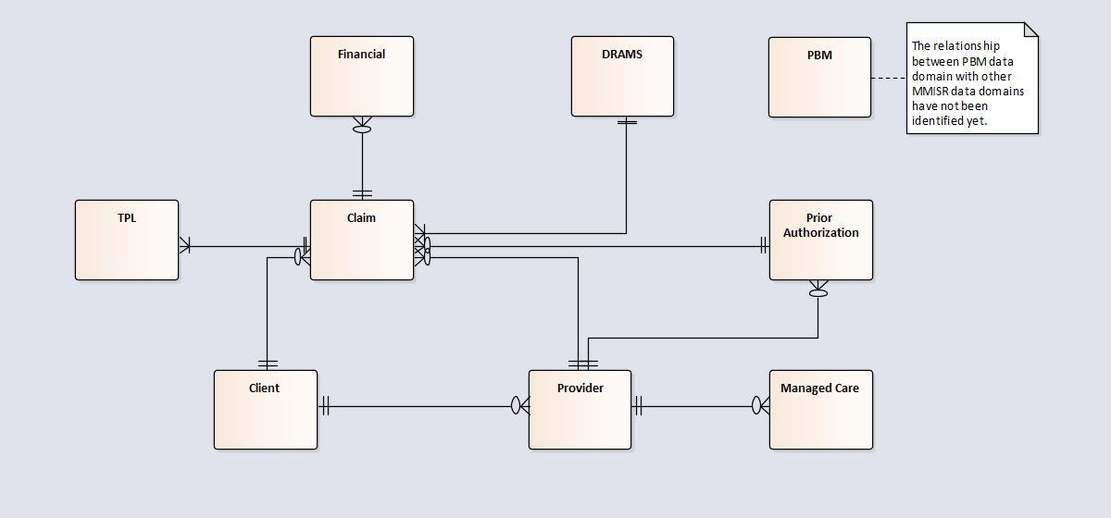
Figure 35: NM MMISR Conceptual Information Model

https://www.cms.gov/Regulations-and-Guidance/Guidance/Manuals/Paper-Based-Manuals-Items/CMS021927.html

